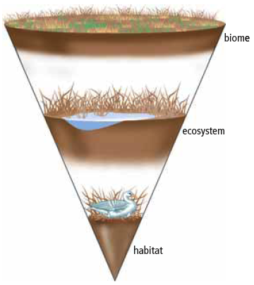
  - Biomes
Definitions:
Biosphere: area near Earth's surface __________________________________ can exist
Abiotic: anything that is __________________________
Biotic: anything that is _________________________
Biomes
Biome: large region that has ____________________________________________
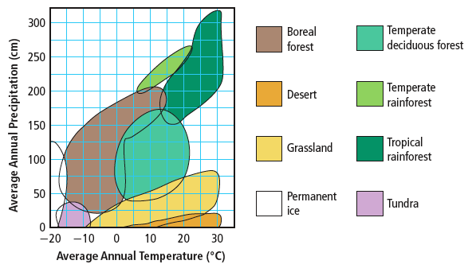
- Certain characteristics help to identify biomes.
  - ____________ and ____________ are two of the
most important abiotic factors.
  - Other factors include __________, __________,
and ___________________.
- Latitude is an abiotic factor that influences biomes.
  - Latitude is the _____________________________________________________.
  - Latitude influences both temperature and precipitation.
    - The tropical zone has very __________ temperatures and __________ precipitation.
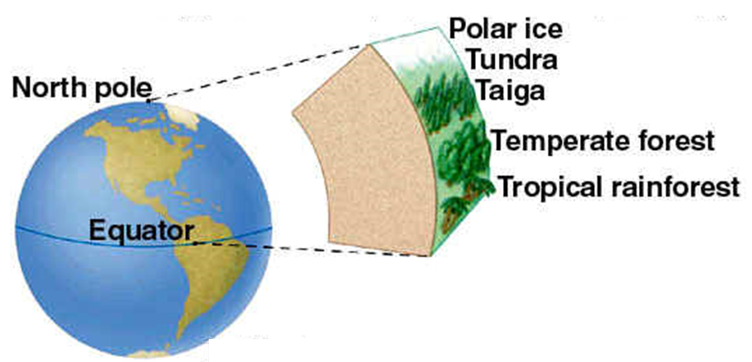
    - The tropical zone receives more ______________________ than do temperate zones.

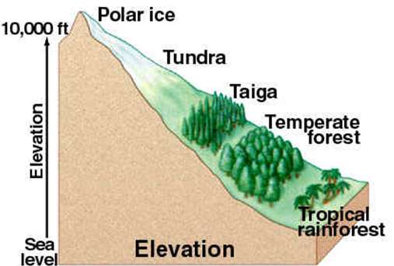
- ______________________ also influences biomes.
  - The atmosphere is thinner at higher elevations, and therefore ________________________ _________________________________

- Ocean currents carry ___________________and _______________ ___ to coastal areas.
  - Where warm currents meet land, temperate biomes are found.

Climatographs
- Climate refers to the average pattern of weather conditions of a large region over a period of 30 years or more.
  - A _________________________________ shows the average ______________________
and _____________________________ for a location over a period of 30 years or more.
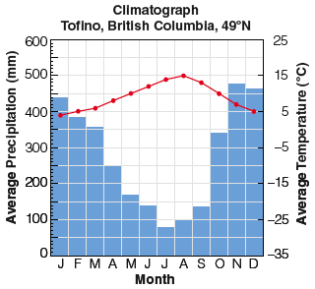
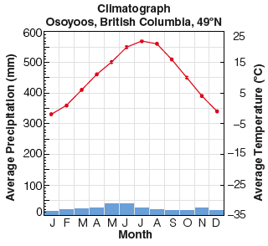
- Biomes are often defined using information in climatographs.
.

Adaptations and Biomes
Biomes are often identified with characteristic biotic factors, such as a cactus in the desert or a caribou on the tundra.
  - Many of these characteristic factors have special ______________________ for that biome.
  - An adaptation is _____________________________________________________________
_________________________________________________________________
    - _______________________________adaptation – a __________________________ that helps an organism survive
      - A wolf has _____________________________.
    - ___________________________ adaptation – a _____________________________ inside the body of an organism that allows it to survive
      - A wolf maintains constant body temperature.
    - ____________________________adaptation – a __________________ that helps an organism to survive
      - Wolves hunt in packs to capture large prey.

