Predator/Prey Relationships: A Case Study Name: Date:

The following graph shows some data collected about a predator/prey relationship in Canada from 1845 to 1940. Answer the following questions using the information from this graph.

Predator - Prey populations from 1845 to 1935

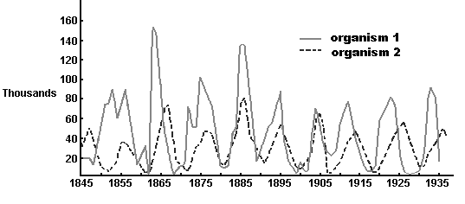
Questions:

Let's focus on the time from 1905 to 1935, since this is the easiest part of the graph to understand.

- When there are many organism 2, what happens to organism 1? (Who is eating who?)

- When there are very few organism 2, what happens to organism 1? Explain what you think is happening.

- When there are few organism 1, what is happening to organism 2? Explain what you think is happening.

- When there are many organism 1, what is happening to organism 2? Explain what you think is happening.

- Based on the data in this graph, who do you think is the predator and who is the prey? Organism 1 or 2? How do you know?

This graph doesn’t always follow a “perfect” predator prey cycle like the one in you textbook on page 47.

- What are some other factors that could affect predator and prey populations? How would these factors affect the populations?

