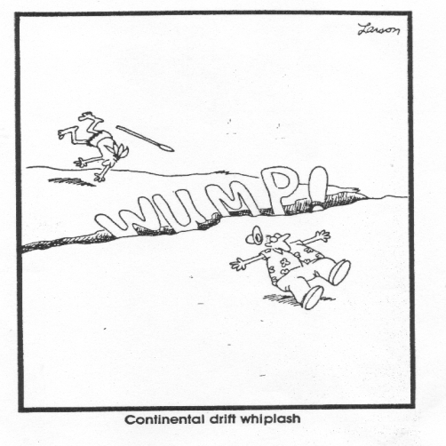
Continental Drift Theory
- ________________________________________________________________________________________________________________________________________________
- _______________________________________________________________________________________________________________________________________________
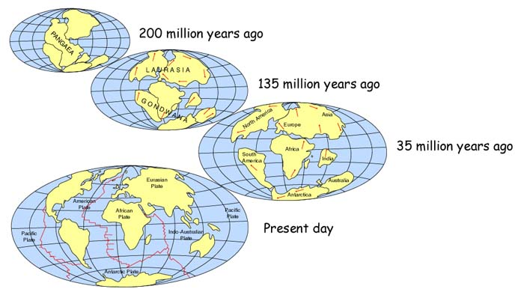

Who proposed the Continental Drift Theory?
- Proposed by _________________________________________________ (1915)
- German scientist
- Based his proposal on 4 lines of evidence:
  - __________________________________________________________________
  - __________________________________________________________________
  - __________________________________________________________________
  - __________________________________________________________________

- Jigsaw puzzle fit of the continents
- ________________________________________________________________________________________________________________________________________________
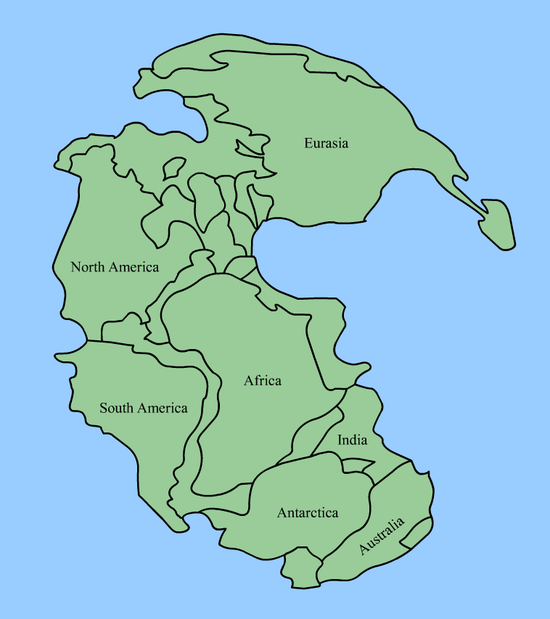
- Led Wegener to propose that continents once fit together and formed a supercontinent called ____________________________________
  - pan = ______________________________
  - gaea = ______________________________

Continents fit together like jigsaw puzzle pieces; especially if you
look at the continental shelves (the original shorelines of the
continents that are now submerged under the ocean).
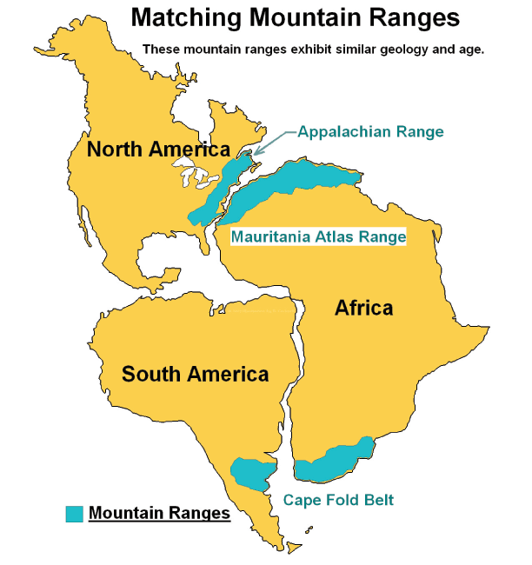
- Matching geological structures
- _____________________________________________

___________________________________________

_________________________________________

_________________________________________

- similar findings exist with rock types and patterns across the Earth’s surface

- Fossils
- __________________________________________________________________________________

__________________________________________________________________________________
- How did the creatures get between the continents?
  - creatures could not swim or fly that great of a distance
- most likely explanation = ___________________________________________________
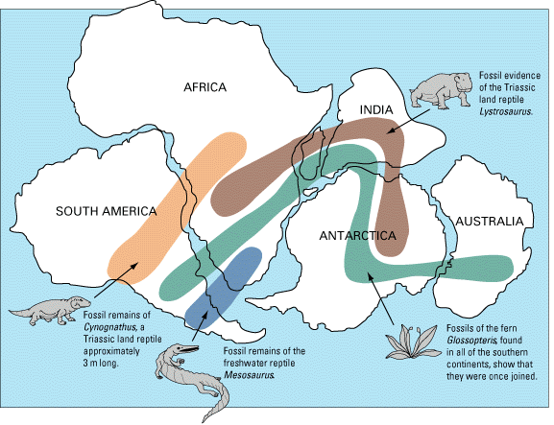
________________________________________________________________________

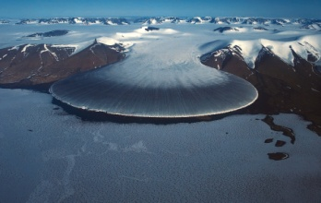
4. Climatic Evidence
- __________________________________________
  - ____________________________________________________________________________________________________________________________________

  - suggest _______________________ may have once been more __________ (allowing for the formation of glaciers)
  - ____________________________________________________________________________________________________________________________________

Ancient glacial rock markings (Paleoglaciation) Proposed location of continents and ancient glacier.

- __________________________________________
  - coal is formed from decay of tropical plants
  - coal deposits are found in Antarctica
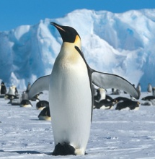
  - ____________________________________________________________________________________________________________________________________

Penguins during Pangaea Penguins Today

- Continental Drift Theory – A Theory Ridiculed
- ________________________________________________________________________
- further evidence would be needed
- was found after Wegener died (1930)
- ________________________________________________________________________________________________________________________________________________

Review Questions

- Which of the following would not be direct evidence that continental drift occurred in the distant past?
- Continents currently move several meters every year
- The shapes of the continents appear to fit together like pieces of a jigsaw puzzle
- Ancient fossils from distant continents are identical
- Rocks and geological structures are identical, or very similar, on different continents

- Why was Wegener so puzzled about finding fern fossils in Antarctica?
- During magnetic reversal events, Antarctica would have become warmer, but not warm enough for ferns to grow
- He thought that all of the paleoglaciation on Antarctica would have scraped away all fossils
- He thought there would also be fossils of animals that ate the ferns there as well, but could not find these fossils
- The same fossils were found on other continents, ferns are a warm-climate plant, and polar climates have never been mild enough for ferns to survive

- Although Wegener presented an interesting theory of continental drift, his ideas were not treated kindly by the scientists of his time. What was the one part of his continental drift theory that he could not convince others was possible?
- The way that continents move through solid ocean floors
- The appearance that the shapes of many continents seem to fit together like a jigsaw puzzle
- That common fossils existed on different continents
- The fact that mountain ranges, valleys and paleoglaciation evidence matches on different continents
Using your textbook:
- What was Mesosaurus? Why are the fossils of Mesosaurus evidence to support Wegener’s theory?

- What was Glossopteris? Why are the fossils of Glossopteris evidence to support Wegener’s theory?

- What is paleoglaciation? How does paleoglaciation give evidence to support Wegener’s theory?

