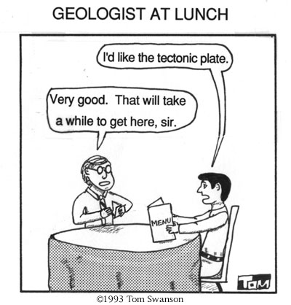
Tectonic Plates
What are Plate Tectonics?
- massive chunks of rock that _________________________________________
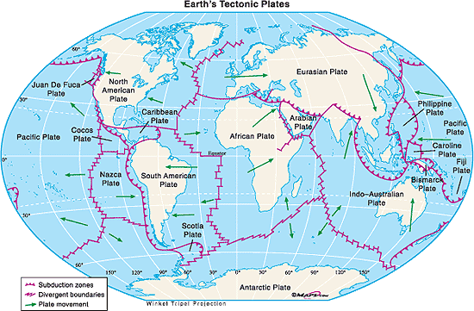
- the tectonic plates ___________________ on the Earth’s _____________
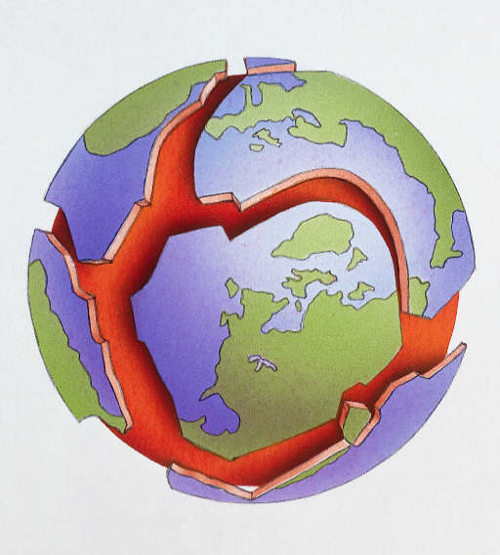

How can we tell tectonic plates move?
- several pieces of evidence including:
  - existence and ________________________________________________________

  - existence of ______________________________

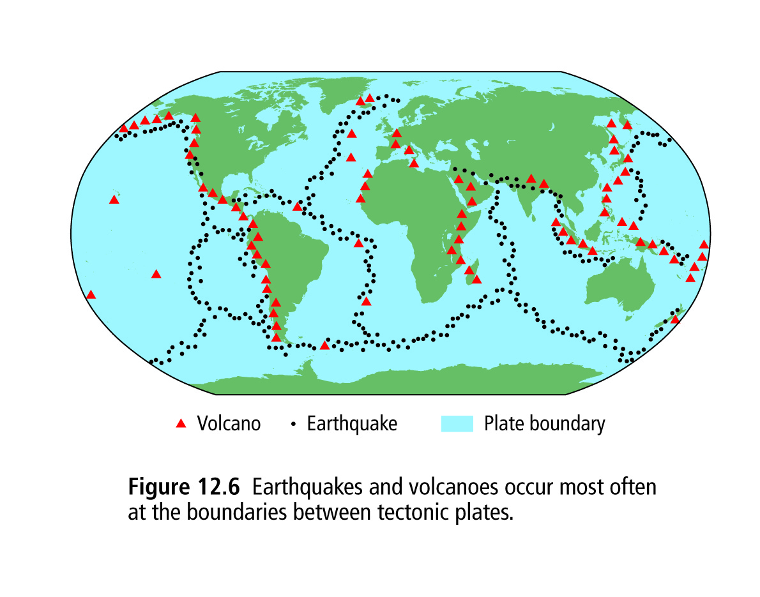
  - existence of ____________________________________________________

  - existence of ______________________________
Earthquakes and Volcanoes
- occur at plate boundaries (the ____________________)
- appear to occur when ______________________________________
- stationary objects cannot collide!!!
- Suggests that ___________________________________________________________
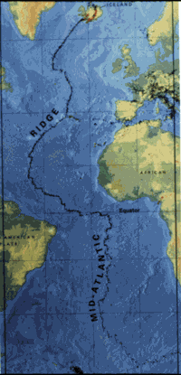
Ocean Ridges
- ______________________________________________________________________________
- Example = Mid-Atlantic Ridge
- can be explained if the plates at the bottom of the ocean are moving apart
  - as plates move apart, a _______________________________
  - ________________ (molten rock below Earth’s surface) then rise through the gap, cools and _____________________________and mountains
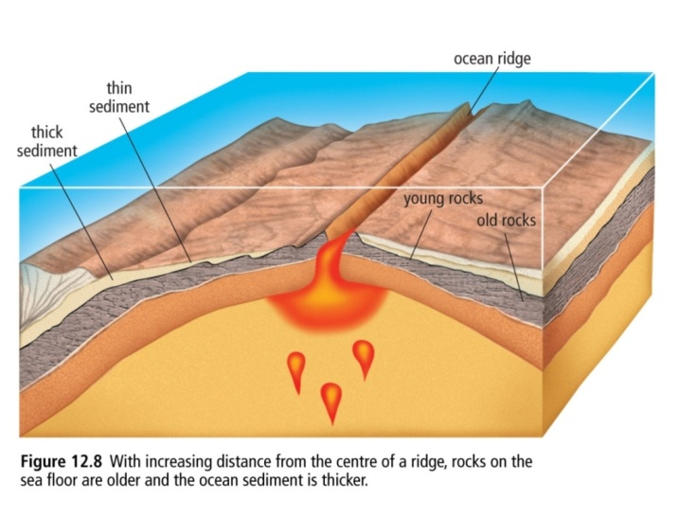
  - Rock _________the ridge is ______________/new rock and thin. Rock __________ away from the ridge is ___________ and thick.

What is magnetic striping? – (Paleomagnetism evidence)
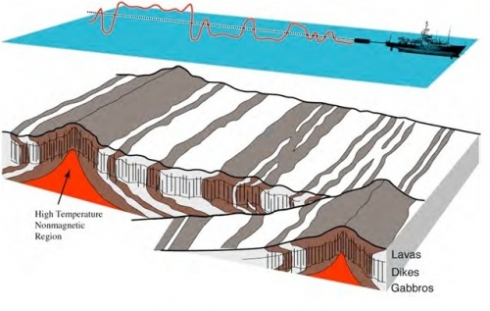
- _____________________ at the bottom of the ocean that have alternating __________________
Magnetic striping
- can be explained if the ________________________ as the
Earth’s _____________________________________
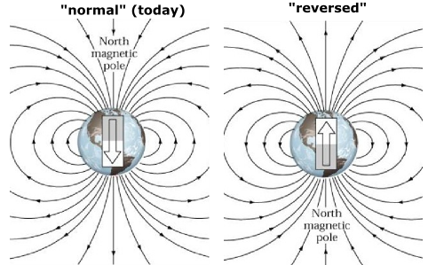

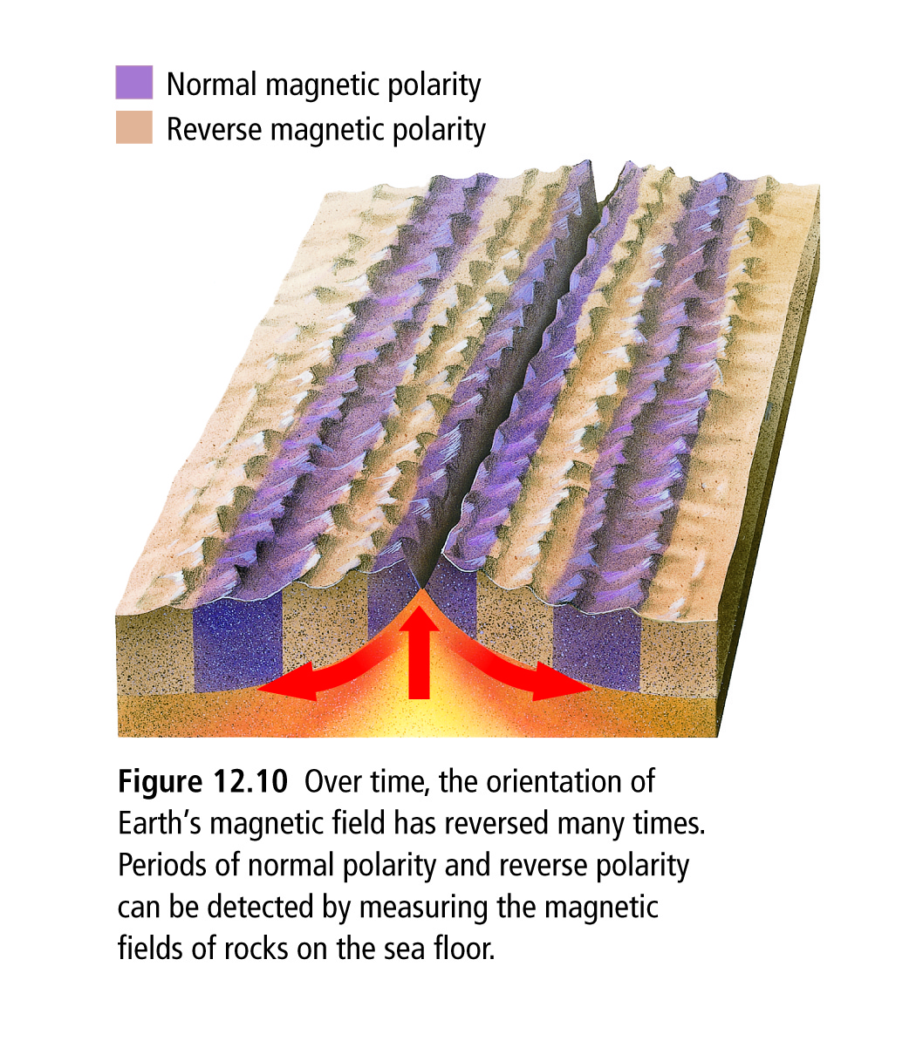

Sea floor spreading
- ocean ridges and magnetic striping suggest that the ________ _______________________________or moving apart
- in other words, the _________________________________

Volcanic Island Chains
- are __________________ that are formed when ________ reaches the Earth’s surface and _____
- can be explained if plates move over a ______________
- hotspots = an area where ________________________________________________________
cools and forms new rock .
- hotspots are _________________________ in the Earth’s molten core
- as the plate moves, the _____________________________
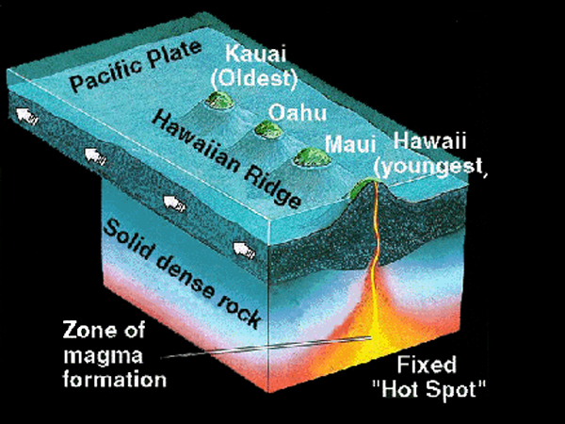
- as a new portion of the _________________________________________________________ until eventually you get a chain of islands
For example, the Hawaiian Islands
- form as the Pacific Plate moves North East over a hot spot\

- Typically, _____________________________________
because the older island has been eroded away over time by the ocean and weather.
Summary of evidence that suggests that tectonic plates can move
- Earthquakes and Volcanoes ___________________________________________
- Ocean ridges _______________________________________________________________
- Magnetic stripes ____________________________________________________________
- Island chains___________________________________________________________
Plate Tectonic Theory
- is a unified theory that came out of the above evidence
- states that the ________________________________________________________________

that float and continually _________________________________________________________

- came about _____________________________ Wegener’s Continental Drift Theory
  - supported Wegener’s theory as it _________________________________________________
    - finally silenced Wegener’s critics because he now had evidence to suggest that the continents were once together in a supercontinent (jigsaw puzzle fit of continents, fossils, geological structures, paleoglaciation and coal deposits) and evidence to support/explain how continents could drift (plate tectonics)

      - Plate tectonics refers to the fact that the surface of Earth is broken into several large "plates" which ride along on what resembles a giant conveyer belt of rock.
Using this analogy, what would be the beginning of the conveyer belt?
- Tectonic plate edges
- Hot spots
- Ocean ridges
- Earthquakes

      - Which of the following is not a piece of evidence to support plate tectonics?
- Sediments on the ocean floor are much thicker close to ocean ridges than near continents
- Long stripes of iron-rich basalt rock with reversing polarity run parallel to ocean ridges
- Ocean floor samples taken near oceanic ridges is much younger than ocean floor samples taken near continents
- Much of Earth's volcanic and earthquake activity occurs along the boundaries of tectonic plates

      - Which part of the plate tectonic theory explains what actually makes the plates move?
- Volcanoes
- Sea floor spreading
- Paleomagnetism
- Earthquakes
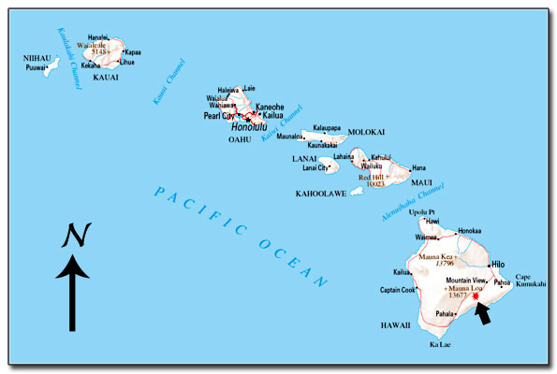
      - The Hawaiian Islands formed over a hot spot in the ocean floor. Which direction is the ocean floor moving in this location?
- Southwest
- Southeast
- Northwest
- Northeast

      - New rock is created at ocean ridges, pushing the older ocean floor away from the ridge. What causes the new rock to form?
- Convection currents in the magma below the ocean floor
- Volcanic eruptions
- Earthquakes in the ocean crust
- Movement of the ocean crust over hot spots

      - The theory of continental drift named a key part of this idea Pangaea. What is Pangaea?
- One of the ancient animals that helped Wegener prove that fossils from different continents originally came from the same location
- The hot spot which gave rise to the Hawaiian Islands, among others
- The underwater ocean range in the middle of the ocean
- A supercontinent that existed in Earth's distant past
Chapter 12 Vocabulary: LOTS of BIG words!

Asthenosphere
Continental Drift Theory
Crust
i. Continental crust
ii. Oceanic crust
Density
Earthquake
Epicenter
Fault
Focus
Geologic time
Hot spot
Inner core

Lithosphere
Magnetic polarity
(normal, reverse)
Magnetic reversal
Magnetometer
Mantle
Mantle convection
Mantle plume
Mid-ocean ridge
Mountain range
Outer core
Paleoglaciation

Plate boundary
i. Convergent
ii. Divergent
iii. Transform
Plate Tectonic Theory
Primary waves (P-waves)
Ridge push
Rift valley
Seafloor spreading
Secondary waves (S-waves)
Seismogram
Seismograph
Seismometer

Slab pull
Spreading ridge
Subduction
Subduction zone
Supercontinent
(e.g. Pangea)
Surface waves (L-waves)
Tectonic plate
Transform fault
Trench
Volcanic belt
Volcanic island arc
Volcanoes

