Volcanoes and Earthquakes
Volcanoes
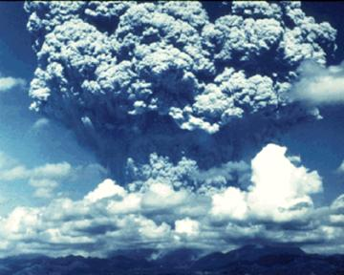
- The term volcano comes from the name of the Roman god of fire, _______________.
- There are different types of volcanoes.
  - ___________________ Eruptions like we see in the movies
  - Slowly flowing __________________ eruptions
So why are some volcanoes more "explosive" than others?
  - The _____________________________ inside the magma is one of the things that determines how violent an eruption will be.
The more dissolved gas, the more explosive!
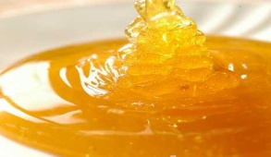
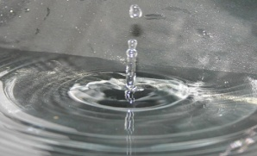
The VISCOSITY of Magma HIGH (honey) LOW (water)
________________ measures the thickness of a fluid

  - _____________________ magma slows down the escape of gases and may also block a volcano’s main vent.
  - When it finally breaks through it is _________________________.

Pyroclastic Flows
Explosive volcanoes can release tiny pieces of ____________________________________________________
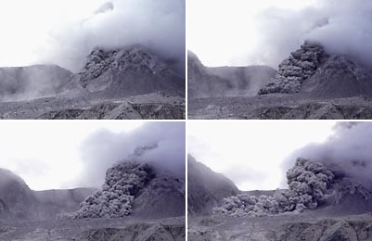
In super explosive eruptions glass and gases can combine to form dense, super heated cloud that travels down hill at high speeds= __________________________________

The 3 types of Volcanoes
The _________________ of ______________________________ produces 3 distinct types of volcanoes:
  - _______________________
  - _______________________
  - _______________________

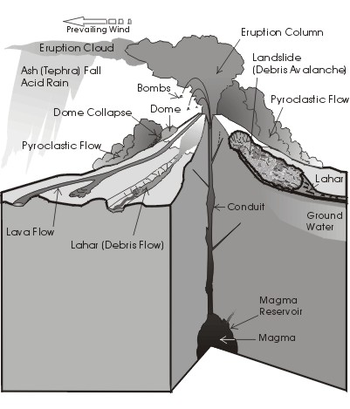
- Composite Volcanoes
  - ______________ shaped, steep
  - ________________ eruptions
  - build up of layers of ash and lava
  - thick magma traps gas then explosively erupts
  - found near __________________________
  - form ______________________________
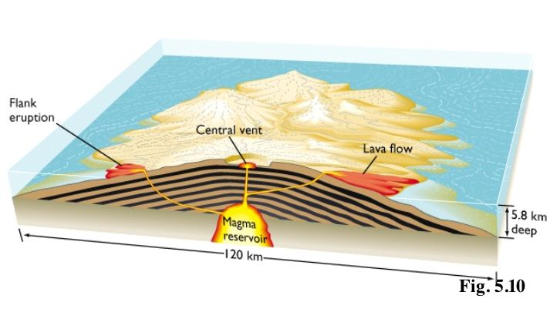
- Shield Volcanoes
  - ________________ volcanoes
  - gentle slopes
  - form over ___________________
  - usually occurs in thinner oceanic crust but some in
continental crust
  - ___________________ means less explosive, tend to flow easily
  - Examples: Hawaiian Island Chain

- Rift Eruptions
  - occur when magma erupts through long ________________________ in the__________________
  - not particularly violent
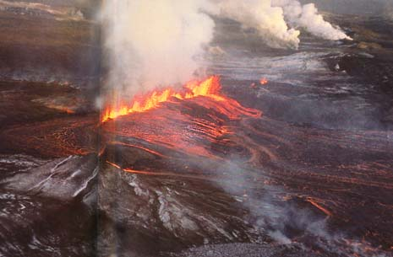
  - create lava curtains
  - release ______________________ amounts of ______________

Why can Volcanoes be so Dangerous???
  - _____________________________________________________________ and debris (pyroclastic flows)
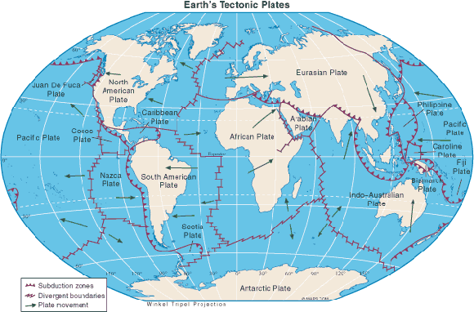
  - Volcanic _________________________
  - Landslides and _____________________ (mudflows)
  - ________________________ or deposits

Earthquakes
Where do earthquakes occur?
____________ occur at plate boundaries where the edges of the plates are in contact with each other
What is an Earthquake?
- An earthquake is the shaking of the ground caused by a sudden _____________________________________ _________________________ at or under Earth's surface.
- They occur at ____________________ types of Boundaries
- Most of the time ______________________ prevents plates from moving but eventually the ________________ becomes __________________________ than the friction and the ___________________________.
- The movement occurs along a _____________________
Describing an Earthquake
- _____________________ = The point at which the ___________ movement occurs ( where the rocks first move)
  - This usually occurs many kilometers below
- _____________________ = The point at Earth’s surface ___________________ the earthquake’s ____________
Seismology
- When an Earthquake occurs it releases its ______________________________ in the form of WAVES.
  - These are called: ________________________
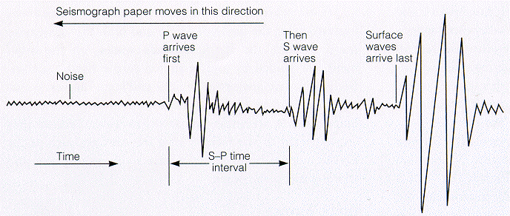
- Seismology is the study of Earthquakes and the energy waves that it releases
- There are 3 different types of waves:
  - ____________________
  - ____________________
  - ____________________
Seismic Wave | Description | Ground Motion
P – Wave | - Primary wave (1st to arrive)  - travels through solid, liquid and gas
S – Wave | - Secondary wave (2nd to arrive)  - travels through solid only  - greater damage
L – Wave | - Love wave (last to arrive)  - roll along Earth’s surface

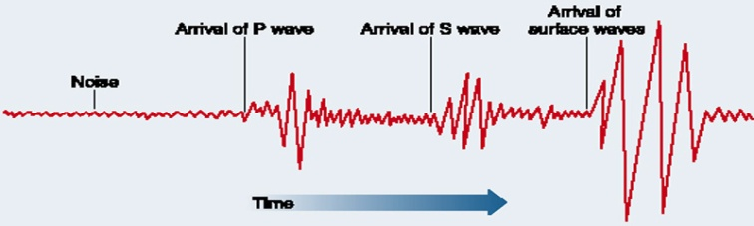
Types of Waves on a Seismograph
- It is the ____________________________________ of
the P-waves and the S-waves that tells scientists how far
they are from the epicenter of the earthquake!

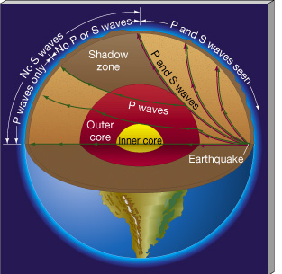
- Only _____________________ can travel through the Earth’s liquid outer
core!
- _____________________________ penetrate the Outer Liquid Core

How do we Measure Earthquakes???
- _________________________ = measures ground movement
- _______________________ = a recording of the ground movement
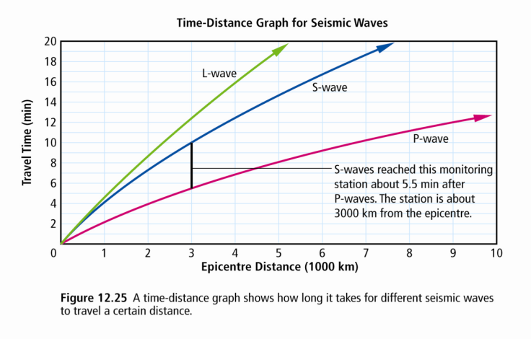
- __________________________ = size of earthquake based on size of waves
S-P Interval
- The amount of time between when the P-waves first arrive
and the S-waves arrive
  - Allows us to calculate ____________________________________

The Richter Scale
- The ____________________ measures the amount _________________________________ using a _____________________
  - each whole number increase on the magnitude scale = a ______________________ in the size of waves
  - magnitude 2.0 = _____________________________________________
  - magnitude 6.0 = _____________________________________________
  - magnitude 8.0 = ____________________________________________
  - difference in wave size from magnitude 2.0 to 6.0 = _______________________
= _________________________ bigger (____________________________)

Practice!
- Which of the following best describes shield volcanoes?
- Tall, cone-shaped volcanoes, often found underwater, that form over thin spots in the lithosphere called hot spots
- Wide volcanoes, often found underwater, that form over thin spots in the lithosphere called hot spots
- Wide volcanoes, formed by repeated eruptions of thick lava and ash
- Tall, cone-shaped volcanoes formed by repeated eruptions of thick lava and ash

- Where is a shield volcano most likely to occur?
  - in a mountain range
  - at a spreading ridge
  - over a hot spot
  - under a subduction zone

- Where is a composite volcano most likely to occur?
  - in a mountain range
  - at a spreading ridge
  - over a hot spot
  - over a subduction zone

- Where is a rift volcano most likely to occur?
  - in a mountain range
  - at a spreading centre
  - over a hot spot
  - under a subduction zone

- Which type of volcano is most likely to have the most explosive and violent eruptions?
  - Composite volcano
  - Shield volcano
  - Rift volcano
  - All types of volcanoes are equally likely to be explosive and violent.

- A magnitude 6.6 earthquake occurred on November 2, 2004, 560 km west of Tofino. The actual earthquake originated at a depth of 10 km.
Which of the following statements is correct?
- The focus of the earthquake was 10 km below the ocean surface
- The focus of the earthquake was 560 km west of Tofino, on the ocean's surface
- The epicentre of the earthquake was 560 km west of Tofino, on the ocean's surface
- The epicentre of the earthquake was 10 km below the ocean surface
- Which is the correct order for the following volcanoes?
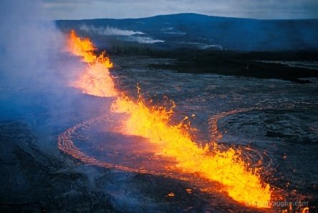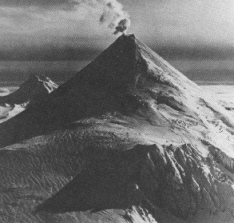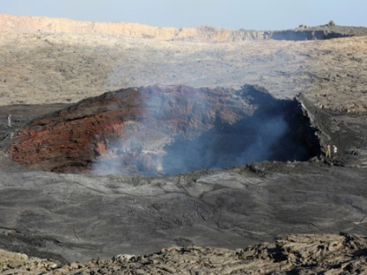
  - rift, shield, composite
  - shield, composite, rift
  - rift, composite, shield
  - composite, shield, rift

- A large earthquake occurs 100 km away from where you are playing soccer one evening. You would feel the P-waves about 17 seconds after the earthquake occurred, followed by the S-waves 13 seconds later. Finally, the L-waves would arrive, causing the earth to move more than the other two types of waves.
Which of the following statements is true?
- The L-waves, arriving last, do the most damage because they move through the body of Earth by squeezing and stretching like a spring
- The L-waves, arriving last, do the most damage because they move along the surface like ocean waves
- The S-waves are slower and do less damage than P-waves, since they are smaller waves than P-waves
- The P-waves, arriving first, do the most damage because they move along the surface like ocean waves
- If a large earthquake occurs in Australia, which type of earthquake wave can be measured in British Columbia, all the way on the other side of the planet?
- S-waves, since they travel through the molten centre of Earth
- L-waves, since they travel along Earth's surface
- P-waves, since they stretch and compress like a spring
- P-waves, since they stretch and compress like a spring and can travel through all types of materials
- What instrument records the ground shaking caused by earthquakes?
  - Magnetometer
  - Barometer
  - Seismograph
  - Seismometer

