Plate Boundaries
Two Types of Plates
- _________________ Plate:
  - More Dense and _________________
  - Made of a specific rock called BASALT
- _________________ Plate:
  - Less dense and _________________
  - Made of a specific rock called GRANITE
When these two types of plates interact, the _________________ Plate ALWAYS _________________ below the continental plate.
Plate Boundaries…
At the _________________ of the plates is where all the _________________ occurs
When Plates move – there are only _____ choices they have…
1) Separate from each other (_________________)
2) Crash directly into each other and one goes under the other (_________________)
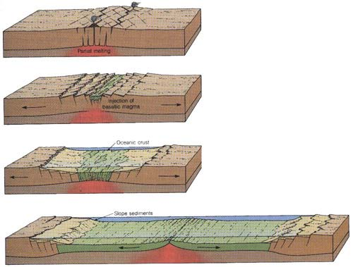
3) Slide past/along one another (_________________)
The 3 Types of Plate Boundaries
#1-DIVERGENT boundaries
Two plates ________________________________from each other opening a gap called a spreading center
There are 2 types:
- Oceanic-Oceanic
- Continental- Continental
As molten rock comes up through the trench created by the diverging plates, it pushes the old crust aside causing it to buckle. This process is called __________________________________

____________________

- Diverging Over Water… (Oceanic-Oceanic)
When tectonic plates diverge, pull part, over water, the spreading center is called ______________________________ or__________________________________
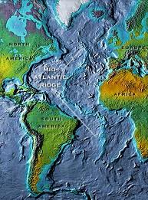
Because the magma rises up through the crack and pushes the old crust aside, new sea floor is created. This is called __________________________________________________________
The Mid Atlantic Ridge is formed by Diverging Oceanic Plates
It is an area in the middle of the Atlantic Ocean that is forming an ocean ridge
during sea floor spreading

- Divergent plates over land… (Continental-Continental)
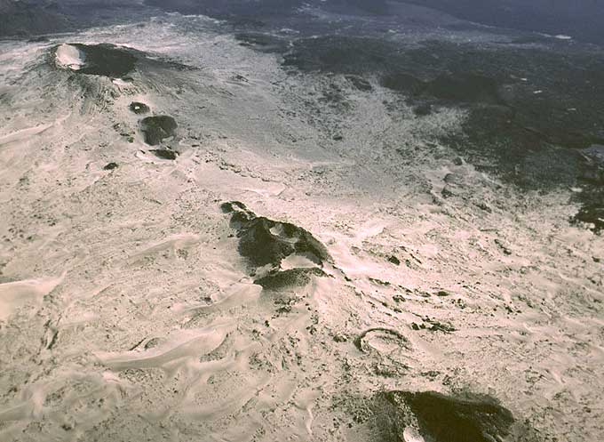
When tectonic plates diverge, pull apart, ____________________________, the spreading center is called a __________________________________.
This is less common than spreading over water
Diverging plates in eastern Africa are slowly breaking Africa into pieces creating rift valleys at the spreading centers

#2- CONVERGENT Boundaries
When 2 plates _______________________________________each other
The plates will do 1 of 2 things:
- One plate will _________________ underneath of the other plate, this is called _________________
- The two plates will _________________ with one another without the sinking of plates
There are _________ types of Convergence:
  - Oceanic- Continental
  - Oceanic-Oceanic
  - Continental-Continental
Convergent Plates with Subduction
When _________________ occurs – the edge of the plate subducts deep into the mantle and starts to melt creating ____________________.
When the plate subducts, it “pulls” the rest of the plate with it - This is called __________________________________ (the whole slab is pulled under the other slab)
This slab pull helps keep the tectonic plates in motion.
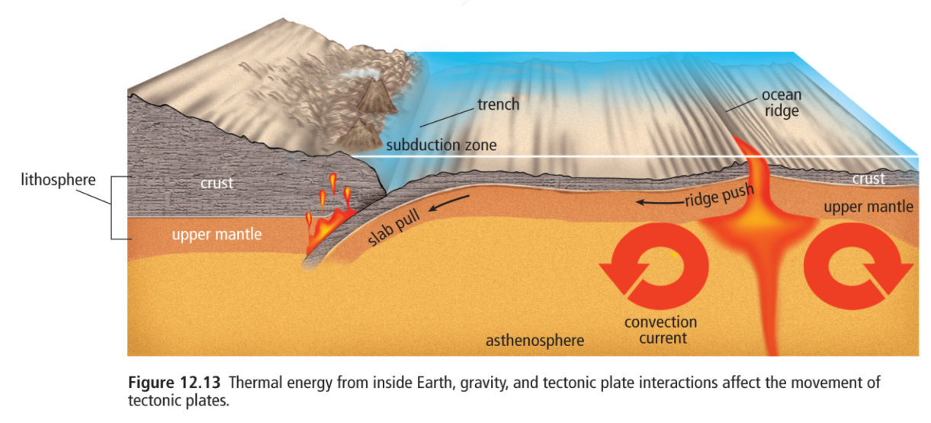
Subduction, Ridge push, and Slab pull

- Oceanic-Continental Plate Convergence…
When a dense (heavier) oceanic plate collides with a less-dense (lighter) continental plate, the __________________________________.
This creates a deep underwater valley called a _______________.
As the subducting plate moves deeper, magma can work its way to the surface forming cone-shaped Volcanoes
A chain of volcanoes = __________________________________
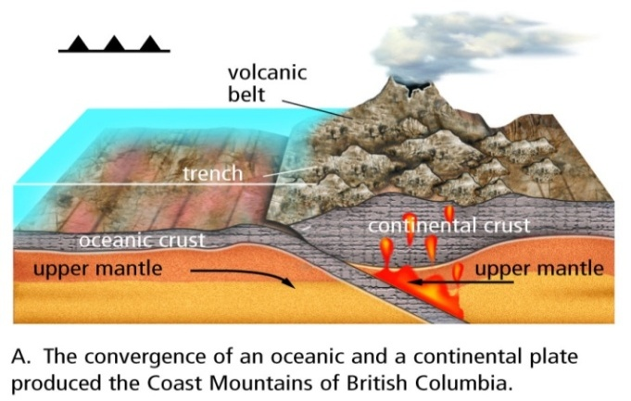
This force of collision between the 2 plates creates _________________________________as the continental rock crumbles and folds
Oceanic – Continental Convergence
Symbol for convergence on maps

- Oceanic - Oceanic Plate Convergence…
Subduction occurs when 2 oceanic plates converge/collide.
The _________________________________under the other, and the subducting plate sinks deep into the mantle
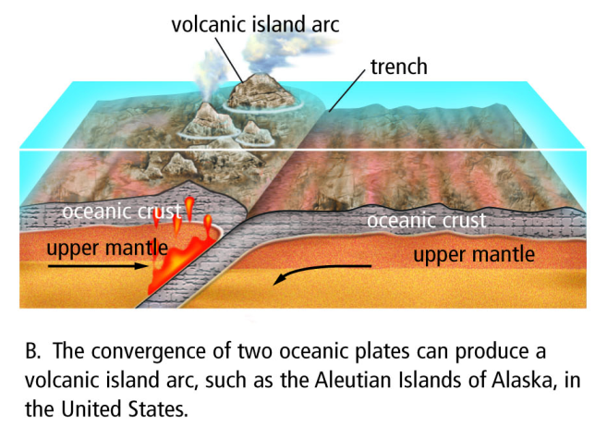
This interaction may produce a long chain of volcanic islands known as a __________________________________________________( ie. Japan islands)
Oceanic – Oceanic Convergence

- Continental - Continental Plate Convergence…
When continental plates collide, subduction____________________________________ occur because the plates are the same density.
Instead, the plates ________________________________ and their edges crumple and fold forming great ___________________________________ (ie. The Himalayas)
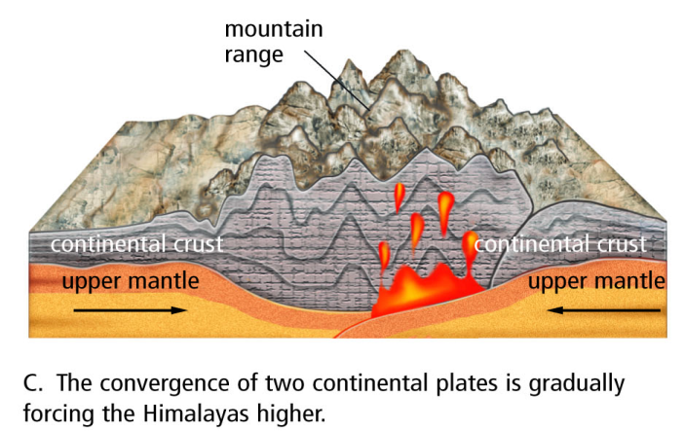
The Himalayas are the highest and youngest mountain range and are increasing in height several cm a year due to continuous convergence of the plates!

Continental- Continental Convergence

#3- Transformation boundaries
2 plates ________________________________ one another
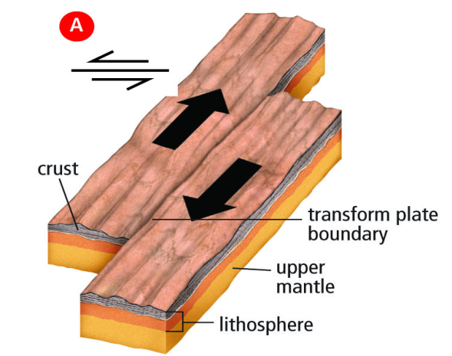
Because they are sliding horizontally past each other – _______mountains or volcanoes are _________________
Transform Faults
What do form are _________________ and _________________
Faults are cracks in the rock due to movement
_____________________________________are the name we give to the area where the plates slide

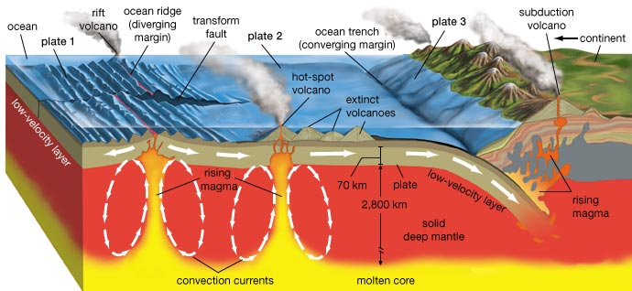

The following illustration depicts the movement of tectonic plates.
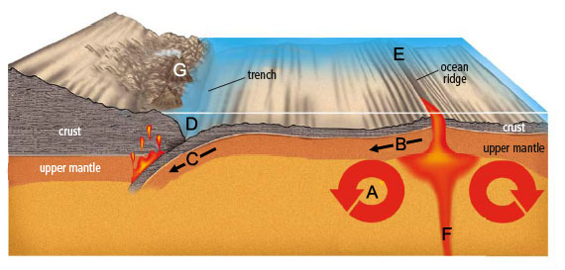
1. What is the name of the process occurring at C, where one part of a tectonic plate tugs the rest of the plate along as it returns into the lower portions of the mantle?
- Slab push
- Slab pull
- Ridge push
- Ridge pull

2. Subduction zones are sites of convergent plate interactions. Here, a more dense tectonic plate pushes below a less dense tectonic plate, forming a trench. In the illustration, where is the subduction zone, or trench?
- E
- D
- A
- F

3. What is the name of divergent boundary found on land that exhibits the same process that occurs at E?
- Volcano
- Earthquake
- Rift valley
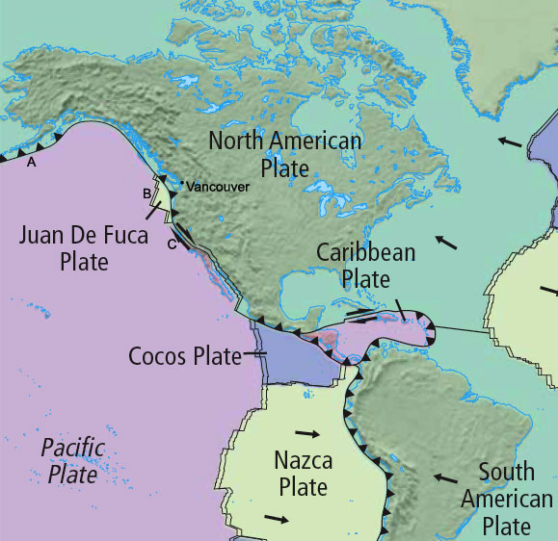
- Ocean ridge

4. In order, what are the plate boundaries located at A, B and C?
- Divergent, Convergent and Transform
- Convergent, Divergent and Transform
- Transform, Convergent and Divergent
- Convergent, Transform and Divergent

5. What has formed at the east side of the Caribbean plate?
- mountains
- volcanic island arc
- earthquakes
- island chains over a hotspot.

6. What is the difference between a volcanic island chain and a volcanic island arc?

7. Draw a large diagram to help you review plate boundaries. Your diagram (or diagrams if you cannot think of how to put everything onto the same picture) must include:
convergent boundary _______ subduction zone _______ trench _______

divergent boundary _______ ocean ridge _______ rising magma _______

rift valley _______ convection current _______ transform fault _______
ridge push _______ slab pull _______ crust _______
tectonic plate _______ asthenosphere _______ lithosphere _______

hot spot _______ volcanic island chain _______
Put a beside each word after you have put it on your diagram so you know when your diagram is complete.

