2.1 Energy Flow in Ecosystems
- Biomass is the _____________________________________________________________________________.
  - Biomass can also refer to the mass of a particular type of matter, such as organic materials used to produce biofuels.
  - Biomass is generally measured in _______ or ________ .
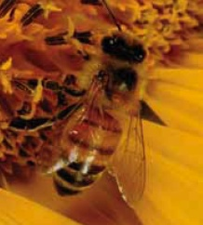
- Within an organism’s niche, the organism interacts with the ecosystem by:
    - _________________________________________from the ecosytem.
    - ___________________________________________to the ecosystem.
  - Plants are called ___________________________ because they produce sugars
from carbon dioxide, water and the __________________ ___________.
  - ________________ get their energy by __________________________
or other consumers.
  - Decomposition is the breakdown of wastes and dead organisms
by organisms called ____________________through the process of _________________.
- Scientists use different methods to represent energy moving through ecosystems.
  - __________________________
  - __________________________
  - __________________________
- Food chains show the _________________________ in an ecosystem
- Each step in a food chain is a __________ __________________
  - _________________________________ = 1st trophic level
  - _________________________________ = 2nd trophic level
  - _________________________________ = 3rd trophic level
  - _________________________________ = 4th trophic level

- Consumers in a food chain can be classified as:
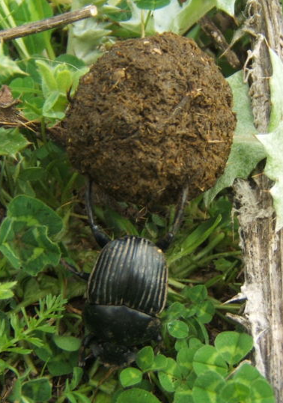
  - Detrivores - consumers that obtain energy and nutrients from ____________________________
_______________________________________________
    - Examples include __________, _______and ___________.
    - Detrivores feed at every trophic level.
    - Detrivores have their own, separate food chains and are very numerous.
  - Herbivores – _______________________________________
    - Herbivores eat __________ (producers) only.
  - Carnivores – _________________________________________
    - Secondary consumers eat non-producers, such
as _______________.
    - Tertiary consumers eat secondary consumers.
      - Also called _________________ or _____________________.
  - Omnivores – consumers that __________________________ and ________________
    - Examples include humans and bears.
Most organisms are part of many food chains.
- Food webs represent interconnected __________ ______________.
- Food webs are models of the feeding relationships in an ____________________.
- Arrows in a food web represent the _________________________________________________.
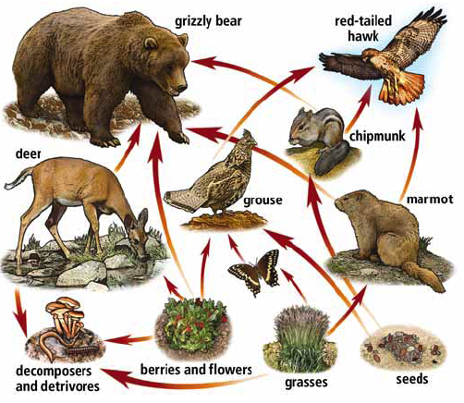
- Following the arrows leads to the ___________________________________________________.

- Food pyramids show the ___________________________ from one trophic level to another in a food chain.
  - Energy enters at the _____________________ (producers), where there is a large amount of biomass and therefore much energy.
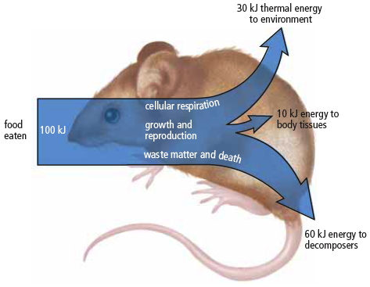
  - It takes large quantities of organisms in one trophic level to meet the energy needs of the next trophic level.
    - Each level loses large amounts of the _______ it gathers through basic processes of living.
    - 80 – 90 percent of energy taken in by consumers is used in __________________ in the body and is lost as ____________________________
    - There is very little energy left over
for ________ or _______________________________.
- Food pyramids are also known as ecological pyramids.
  - Ecological pyramids may show ____________________, __________________, or ________________________________.
  - The amount of life an ecosystem can contain is based on the ____________ _____________ of the ecological pyramid, where __________________capture energy from the __________.
  - Each level in the energy pyramid = a loss of ____________________________________________.
    - Lower trophic levels have much larger _________________________ than upper levels.
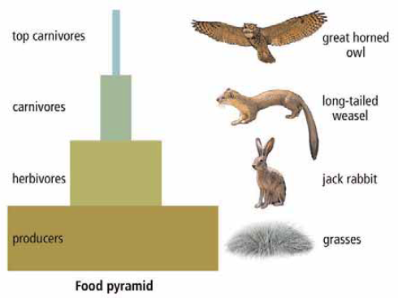
    - This shows the importance of maintaining large, biodiverse populations at the lowest levels of the food pyramid.

