2.2 Nutrient Cycles in Ecosystems – Nitrogen & Phosphorous
What About Nitrogen???
- Nitrogen is very important in the structure of ________________________________________________.
  - In animals, proteins are vital for ___________________________________________.
  - In plants, nitrogen is important for__________________________________________.
- The largest store of nitrogen is in the ____________________________________________.
  - Approximately __________________________of Earth’s atmosphere is N₂ gas.
  - Nitrogen is also stored in ___________________, and as organic matter in __________________.
  - Smaller nitrogen stores are found in terrestrial ecosystems and waterways.
So How does Nitrogen Cycle?
- Nitrogen is cycled through processes involving plants.
  - _____________________________________
  - ____________________________________
  - ____________________________________
1. Nitrogen fixation is the conversion of ____________ into compounds containing ________________ ________________________________________________.
  - Nitrates and ammonium are usable by plants.
Three ways of fixing nitrogen:
    - _________________________ – _____________ provides the energy for N₂ gas to react with O₂
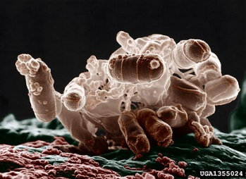
      - Compounds formed by these ions then __________________________via precipitation.
      - This provides only a small amount of nitrogen fixation.
- ______________________ – _______________________________ like Rhizobium convert N₂ gas into ammonium.
      - The plants provide sugars, while bacteria provide nitrogen ions. (symbiotic relationship)
- ________________ – some _________________________convert N₂ into ammonium during the process of photosynthesis.

2. Nitrification occurs when certain soil bacteria _______________________________________.
  - Ammonium is converted first to nitrite (NO₂–), and then to nitrate (NO₃⁻).
_______________________ enter plant roots through the process of:
3. _____________________________.
  - These nitrogen compounds compose plant proteins.
  - Herbivores then eat plants for DNA and protein synthesis.
- Nitrogen is returned to the atmosphere via ____________________________________.
  - _________________________ are converted back to________________________________________.
  - N₂ is also returned to the atmosphere through volcanic eruptions.
The Whole Nitrogen Cycle:
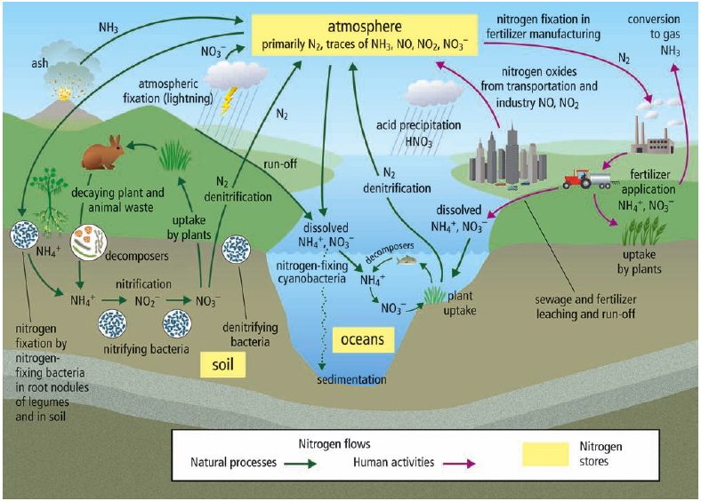
- Excess nitrogen dissolves in water, enters the waterways, and washes into lakes and oceans.
- The nitrogen compounds eventually become trapped in sedimentary rocks and will not be released again until the rocks undergo hundreds of years of weathering.
Human activities can also affect the nitrogen cycle.
- Due to human activities, the amount of nitrogen in the ecosystem has _________________________________.
  - _______________________ and treating sewage releases nitrogen oxide (NO) and nitrogen dioxide (NO₂).
    - Burning also releases nitrogen compounds
that increase _____________________________________ in the form of nitric acid (HNO₃).
  - Agricultural practices often use large amounts of nitrogen containing ____________________________.
    - Excess nitrogen is washed away, or ______________________, into the waterways.
    - This promotes huge growth in aquatic algae called _____________________________________.
    - Algae blooms __________________________________________, killing many aquatic organisms.
    - Algae blooms can also produce neurotoxins that poison animals.
The Phosphorous Cycle
- ________________________ is essential for life processes in plants and animals.
  - a part of the molecule that carries energy in cells.
  - promotes _________________________, stem strength, and _________________________.
  - phosphorous and calcium are important for _______________________________.
- Phosphorous is ______________________________ in the atmosphere.
  - trapped in phosphates (PO₄^{3–}, HPO₄^{2–}, H₂PO₄–) found in rocks and in the sediments on the ocean floor.
- ________________________________ releases these phosphates from rocks.
  - ________________________________________, via acid precipitation or lichens
  - _____________________________________, including wind, water and freezing
  - Weathering does not occur until there is geologic uplift, exposing the rock to chemical and physical weathering.
- ______________________________________________, which are then eaten by animals.

- ________________________________________ to the environment through mining for fertilizer components.
  - Extra phosphorous, often along with potassium, then enters the ecosystems faster than methods can replenish the natural stores.
- Humans can also reduce phosphorus supplies.
  - Slash-and-burning of forests removes phosphorous from trees, and it then is deposited as ash in waterways.
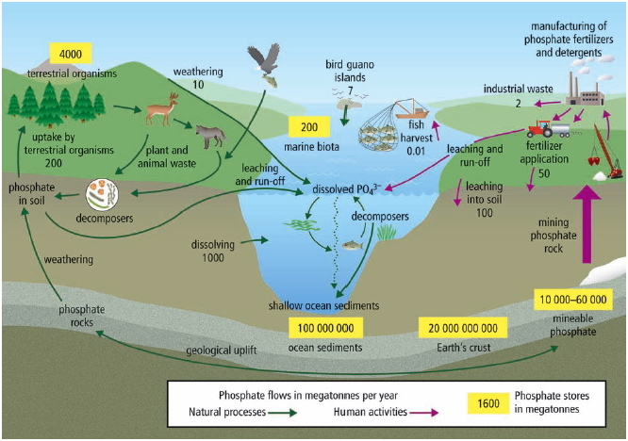
How Changes in Nutrient Cycles Affect Biodiversity
- Any significant changes to any of these nutrients (C, H, O, N, or P) can greatly affect _______________________.
  - Carbon cycle changes contribute to climate change and ____________________________________.
  - Increased levels of nitrogen can allow certain plant species to grow too fast, which kills other plants and decreases resources for every species in the food web.
  - Decreased levels of phosphorous can inhibit the growth of algae that are very important producers in many food chains.

Review
Carbon Cycle
Photosynthesis:
Reactants Products
6CO₂ + 6H₂O + Energy C₆H₁₂O₆ + 6O₂
_____________________ ____________________________________________
Cellular Respiration:
Reactants Products
____________________ _____________________________________________
Glucose (sugar) + oxygen gas carbon dioxide gas + water + energy

Nitrogen Cycle
1) Nitrogen Fixation: N₂ NH₃

2) Dissolves in water: NH₃ NH₄⁺

3) Nitrification: NH₄⁺ NO₂⁻ NO₃⁻

4) Dentrification: NO₃⁻ N₂

Phosphorous Cycle
    - Weathering ________________________________________________________ and releases phosphate into the soil.

    - Organisms _______________ phosphorous.

    - __________________________________________phosphorous to the soil after plants and animals die.

    - Phosphorous becomes ________________________________________________.

