2.2 Nutrient Cycles in Ecosystems

**What are “Nutrients”?**

* Nutrients are____________________________________________________________________.
  + Nutrients move­___________________________________________________________.
  + Nutrients often ______________________ in areas called __________________________.
  + Without interference, generally the amount of nutrients flowing ___________________equals the amount of nutrients _________________________________.
* 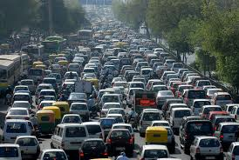Human activities can ___________________________________________ of nutrient cycles.
  + Land clearing, agriculture, urban expansion, mining, industry, and motorized transportation can all

_________________________________________________________________________________.

* + Excess nutrients in the biosphere can have unexpected ________________________________.
* There are five chemical elements required for life.
  + _______________ __________________ ___________________ __________________ cycle between living things and the atmosphere.
  + _______________________________________ cycles in from sedimentary rock.

**The Carbon Cycle**

* + _______________ _____________ are a fundamental unit in cells of all living things.
  + Carbon is also an essential part of _____________________________________________.
* Carbon can be stored in many _______________________________.
  + Short-term storage is found _________________________________________, in___________2 in

the _______________________ and in the top layers of the _____________________.

* + 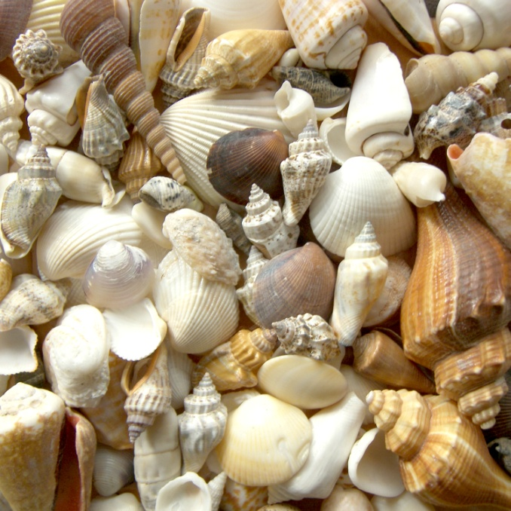____________________________ is found in middle and lower ocean layers as dissolved CO2 and in coal, oil, and gas deposits in land and ocean sediments.

**Carbon Stores**

* __________________________ traps many long-term stores of carbon.
  + Layers of soil and ______________________________become buried on land

and under the oceans. Slowly, under great pressure over many years, coal, oil,

and gas form.

* + _______________________________also are deposited in sediments on the ocean floor, forming carbonate rocks like limestone over long periods of time.
* Carbon stores are also known as___________________________.

**So How Does Carbon Cycle?**

* Carbon is cycled through ecosystems in a variety of ways.
  + ________________________________: energy from the sun allows CO2 and H2O to react

_______________________________ → ____________________________________

* + - Transformed by plants (land), algae and cyanobacteria (ocean)
  + ________________________________: carbohydrates release energy in consumers

______________________________ → ______________________________________

* + - The energy released is used for growth, repair, and other life processes
  + _______________________________: decomposers break down large quantities of cellulose
    - Cellulose is a carbohydrate most other organisms cannot break down
  + _______________________________: CO2 dissolves in cold, northern waters and sinks
    - Ocean currents flow to the tropics where the water rises and releases CO2.
    - This process is called ___________________________
  + _______________________________: volcanic eruptions can release CO2
    - Forest fires also release CO2.

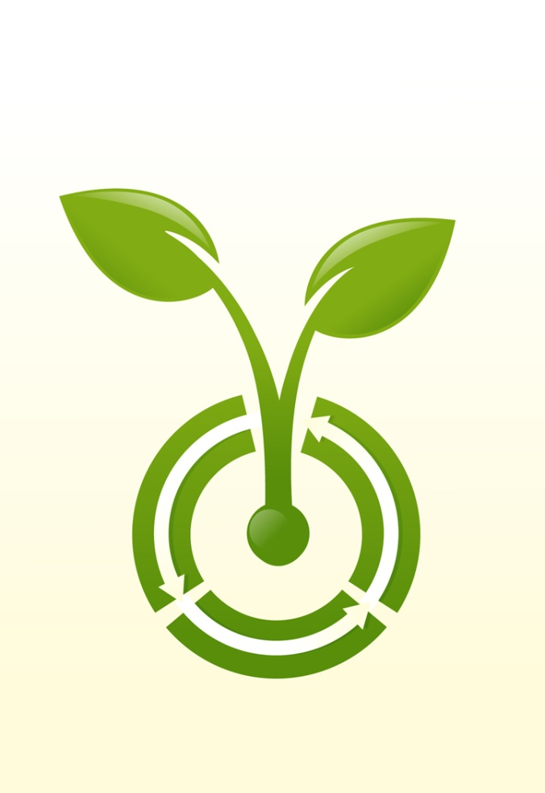**C:\Program Files\Microsoft Office\MEDIA\CAGCAT10\j0332364.wmf**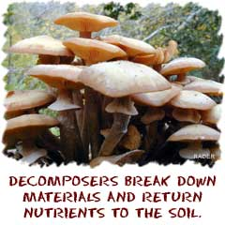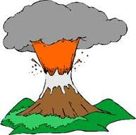

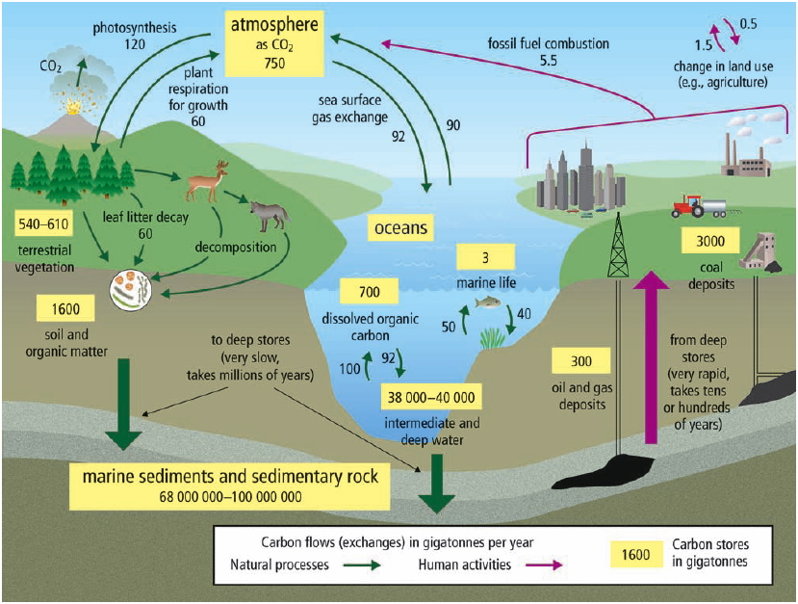**The Whole Carbon Cycle**:

* + Many human activities can influence the carbon cycle.
    - Since the start of the Industrial Revolution (160 years ago), ________________________

______________________________________ due to the increased burning of fossil fuels.

* + - **The increase in CO2 levels in the previous 160 000 years was 1 - 3 percent**
    - Carbon is being removed from long-term storage more quickly than it naturally would as we mine coal and drill for oil and gas.
    - CO2 is also a __________________________, which _________________ in the atmosphere.
  + Clearing land for agriculture and urban development _____________________________________________.
    - Farmed land does not remove as much CO2 as natural vegetation does.

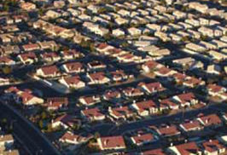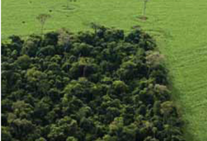

**Carbon Cycle Webquest**

**Directions**: With a partner, visit the following websites and answer the related questions. Your goal is to gain a

better understanding of the carbon cycle. The answers to each question are found on the page if you read

carefully! Write your answers in full sentences. Try to use your own words as much as possible, and don’t copy

something you don’t understand!!

**Background**: In biogeochemical cycles (including carbon, water and nitrogen cycles), elements are transported

between the atmosphere, biosphere (living things), hydrosphere (water), and geosphere (rocks, minerals, and

soils). These cycles help us remember that Earth is a complex system.

**Go to www.windows2universe.org/earth/Water/co2_cycle.html and answer these questions:**

1. Draw the carbon cycle:

1. How does carbon exist in the atmosphere?
2. How are fossil fuels created?
3. Describe two ways that carbon enters the atmosphere.

1.

2.

1. How are the oceans involved in the carbon cycle?
2. How is the temperature of the Earth partly controlled by carbon?
3. What role do rocks have within the carbon cycle?

**Go to www.windows2universe.org/earth/climate/carbon_cycle.html to play the carbon cycle game. You are a carbon atom!**

1. Where are you starting within the carbon cycle?

**“Click to begin your journey”**

1. How much of the atmosphere is made of carbon dioxide (CO2)?
2. By how much has CO2 increased in the atmosphere during the past 150 years?

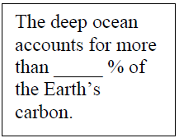**As you work through this game, take some notes about where you go as a carbon atom.**

**Make sure you visit all reservoirs!**

1. Next stop = _________________________________________ What did you learn?

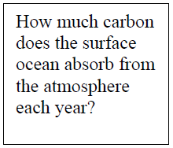

1. Next stop = _________________________________________ What did you learn?
2. 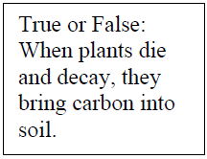Next stop = _________________________________________ What did you learn?
3. Next stop = _________________________________________ What did you learn?

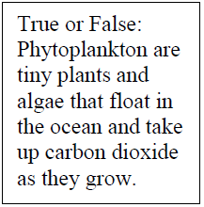

1. Next stop = _________________________________________ What did you learn?

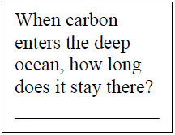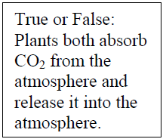

Approximately how many Megatons of Carbon do humans produce by burning fossils fuels each year? (1 Megaton = one million tons)

True or False: The ocean absorbs more carbon dioxide from the atmosphere than the land.