2.3 Effect of Bioaccumulation on Ecosystems
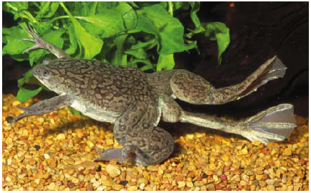
- Amphibians are valuable _____________________________ ___________________________ because they’re sensitive to chemical changes.
- Since the 80s, the world amphibian population has ________________________ & birth deformities have ________________________.
- This may be due to: ____________________, increased UV rays, ___________________________, habitat loss, ___________________________________________.
Keystone Species
- a species on which many other species in an ecosystem depend
- _____________________________________________________________________________.

Bioaccumulation
- ___________________________________: a slow __________________________________ in the bodies of organisms.
  - If bioaccumulation occurs in a ______________________________, it can affect every other organism in its far reaching ___________________.
- Eg. Bioaccumulation of PCBs in the B.C. Orcas.
  - PCBs will affect the reproductive cycles of Orcas until at least 2030, even though they were banned in ‘77.
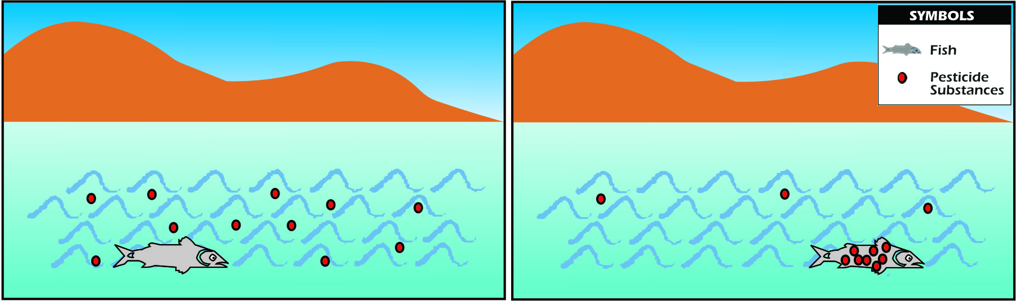
- Chemicals like ________________ and _______________& other insecticides are called ______________________________________________________.
  - _______________contain ____________________, & remain in water & soil for many years (like all organic comp)
  - ______________, even at low levels (5 _____________) causes nervous, immune & reproductive system disorders in animals. [ppm = parts per million]

  - ________________________________ also ______________________________.
  - Lead, cadmium & mercury are the most dangerous.
  - ____________________ is not considered safe at any level, it can cause anemia, nervous & reproductive system damage.
  - ______________________ is toxic to earthworms & causes many health problems in fish.
  - Cadmium causes ___________________, ____________________, ________________
______________________________damage in humans (exposure to cigarette smoke).
  - _______________________ enters ecosystems through burning of fossil fuels, waste incineration, mining & the manufacture of batteries.
  - Coal burning adds ___________ of the mercury released.
  - Mercury ____________________________ in the brain, heart & kidneys of many animals (Fish bioaccumulate mercury, adding risk for any organisms eating fish).
- Reducing the effects of chemical pollution
  - If chemicals are trapped in the soil, they cannot enter the ______________________ as easily.
  - ______________________________: micro-organisms or plants are used to help clean up, and are then removed from the ecosystem.
Eg. The oil industry will often use bacteria to “eat” oil spills.
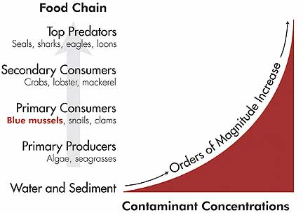
- _____________________________: the consumers in each _____________________ receive larger doses of accumulated chemicals than the one before it.


