3.1 - Natural Changes in Ecosystems
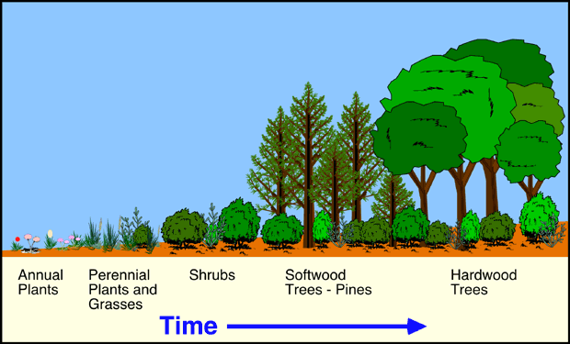
A long time ago….
- The _________ __________of the oceans was much ___________ than they are today
- As the water dropped, new lakes were formed and some species of fish were _____________: some in the ocean, some in the lakes
Natural Selection and Adaptive Radiation
- The fish in the lakes needed to eat different food, and had different predators than those in the ocean
- When a species environment changes, their bodies also change to adapt to that environment and new species are created from one original species

- This is called _____________ ________________

- The ability of living organisms to change to better adapt to their environment is called __________ ________________
- The changes allow the organisms to have an advantage over other members of that species, and they will have better chance to mate, and these advantages are passed on to their offspring
Darwin's Finches Example:

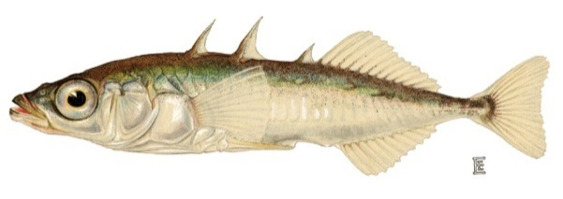
Example: ______________________
_________ Sticklebacks
- Sharp spines and armour-like plates on the body protects against many large marine (ocean) predators
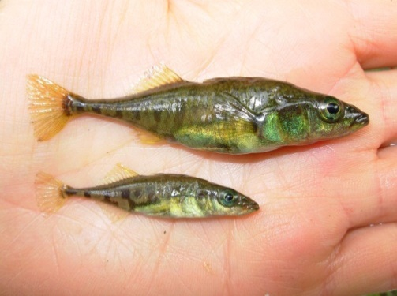
________ Sticklebacks
- Top: bottom feeding stickleback has a large body and big mouth, less armour
- Bottom: open-water feeding stickleback has smaller, thinner body and more armour…..why?

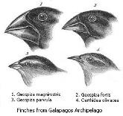
Can you think of any other examples of adaptive radiation?
- ___________________________:
  - African Elephants have larger ears
  - Helps them keep cool in warmer environment
- ____________________: (pg. 110)
  - These birds eat different foods, so their beaks changed to better suit their diet
Definition:_________________ Succession
- Natural, gradual changes in the types of species that live in an area; can be ____________ succession or ______________ succession
- The gradual replacement of one plant community by another through natural process over time
  - Primary: _________ of years
  - Secondary: _________ of years
Primary Succession
- Begins in a place without any soil
  - Sides of volcanoes, landslides, flooding
- Starts with the arrival of living things such as ______and_______that don`t need soil to survive
- Called ______________ ______________
- Soil starts to form as lichens and the forces of ___________ and ___________ help break down rocks into smaller pieces
- When lichens die, they ______________, adding small amounts of organic matter (and ___________) to the rock to make soil
- Simple plants like _________ and __________ can now grow
- These simple plants die, adding more ______, organic material, and __________
- The soil layer thickens, and larger plants such as __________ can grow and begin to take over
- These plants die, add more nutrients to the soil, larger _______ and ________ can survive now
- ___________, small ________, and _____________ have begin to move in
- What was once bare rock now supports a variety of life
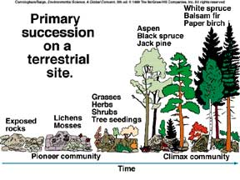
- A stable group of plants and animals that is the end result of the succession process is called a ____________ _________________
- Does not always mean big trees! Ex. grasses in the prairies, cacti in deserts
Secondary Succession
- _______________ Succession is different from primary succession because it begins in a place that already has ______ and was once the home of living organisms
- It occurs __________ and has different pioneer species (grass, flowers) than primary succession
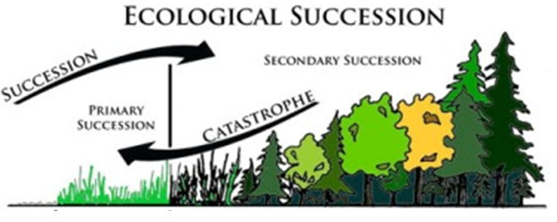
- Example: _________ ___ ___________ ________
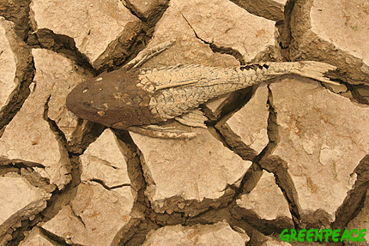

Natural Events That Affect Ecosystems_________: Definition
- Occurs when below-average amounts of ____________ in an area over a period of many _____
- Most often a biome can recover
Drought: Effects
- The effects of prolonged drought can:
  - Destroy __________, cause _________ and __________ to die, result in _____ failure and __________ death
_____________: Definition
  - Huge, rapidly moving ocean wave caused by __________ waves (released by an earthquake or volcanic eruption)

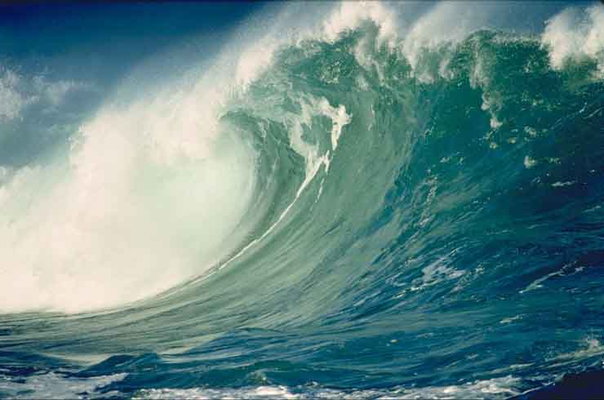
Tsunamis: Effects
  - On land, force of the wave carries away or destroys plants and animals; and can disrupt habitat and food webs
  - The large volume of _______ carried onto the shore can change the composition of the _______, causing plants to be unable to grow
_____________: Definition
- Occurs in __________ areas, _________ and _________, when the volume of water exceeds the ability of the water body to contain it
- Can be part of a normal cycle, result of heavy rainfall, increased run-off, or an extreme natural event
Flooding: Effects
- Can result in soil ____________ and soil _____________ if toxic chemicals are present
- Can cause widespread ___________ among humans when toxins or bacteria from sewage enters drinking water
________ _________________: Effects
- Insects play a natural role in forest succession, _____________ nutrients to the soil.
  - Younger, healthy trees produce resin to defend against insects by flushing them out of the tree
  - When too many insects attack, like in an infestation, the natural defense systems are no longer effective
  - This changes the natural pattern of succession because ____________________________ both old and young trees, leaving none unaffected
