3.2 How Humans Influence Ecosystems
- Human Influences on Ecosystems
  - Wetlands are special ecosystems that contain completely waterlogged soil for long periods of time.
  - Not only do wetlands contain _____________________ _______________________, but they also _______________ many impurities out of the water that slowly flows through them.
  - For this reason, they are sometimes called the “____________________” of the Earth.
  - Because they hold large amounts of water, they can help prevent flooding.
  - In the past 100 years, many wetlands that took _______________________________________________ have been changed into _______________________________________________________________garbage dumps and ________________________________________________!
- “Sustainability” is a word that is used often, and can be defined in more than one way:
  - ____________________________________________________________________________________.
    - These processes enable biodiversity and keep the ecosystem healthy.
  - People using an ecosystem to ________________________________________________ today __________________ ________________________________________________________________________of the ecosystem in the future.
    - Sustainable practices maintain, or even improve, healthy ecosystems.
    - Economic opportunity, biodiversity and ecosystem health are all possible.
- The Effects of Land and Resource Use
  - “Land use” refers to how humans use land around us for urban development, ______________________ _________________________________________industry, mining and ___________________________________________
    - All of the land around us, even in cities, was once a part of an ______________________________.
  - “Resource use” refers to the ways we ________________ and ________________ naturally occurring _____________________.
    - Most products you use every day involve the use of some natural resources in their production.
    - If the land and resources are not used directly, they are often processed and exported to other places for use.
- Habitat Loss
  - The use of land and resources have seen humans encroach on natural ecosystems very aggressively in the past 150 years.
  - As a result of this expansion, habitats have been _____________________________________________.
  - “Habitat loss” refers to the loss of habitats _____________________________________________.
  - “Habitat fragmentation” is the ________________________________________________________________________ ____________________________________________________________________________________, resulting in disrupted natural activities for plants and animals
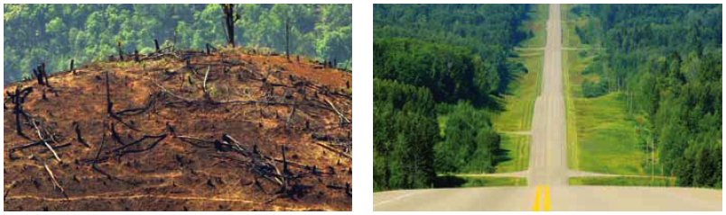
_________________________ _________________________________

- Deforestation is _____________________________________________________________________for human use.
  - The resulting barren land is never __________________________ or _____________________.
  - The agricultural crops that are planted are often one species = ____________________________
    - This reduces biodiversity, and leaves the crop vulnerable to pests or disease.
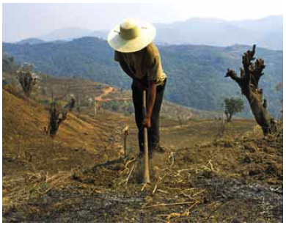
    - __________________________, of many plant species, are more ______________________ and ________________________ diverse.
  - Deforestation is still occurring in many tropical rainforests.
  - Deforestation results in soil degradation.
    - _______________________________ is when moving wind and water erode topsoil and leave bare land behind.
    - Topsoil, the upper layer of soil, is where ________________________________
water and air are found for plant growth.
- If fields are left exposed during non-planting seasons, _____________ and ______________ erosion can occur.
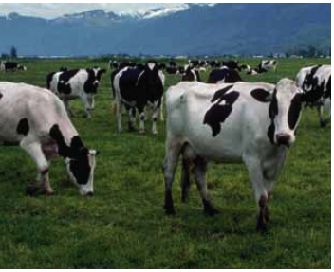
- In areas where over grazing occurs, the _______________________________________.
  - Soil particles are squeezed together and become compacted.
    - This is due to farm animals or vehicles.
  - There is no room for ____________ or _____________ to enter the soil.
  - Water then ____________ _______________ the soil instead of soaking in.
    - Agriculture can cause loss of water, increased erosion and the addition of farm fertilizers and pesticides to the ecosystem.
  - ______________________, which involves removing small plugs of soil, loosens soils and can reduce run-off.
- Resource exploitation = ___________________________________
  - Humans depend on resource exploitation for jobs, materials, food, shelter and energy.
  - Exploitation can lead to _________________________, ________________________ and ___________________________ of water supplies.
    - Contamination is the introduction of ___________________________ or _________________________________________ into the environment.
    - Many mining and resource exploitations require _____________________________ efforts.
      - Reclamation attempts to reduce environmental impacts of exploitation, and tries to restore the original (or at least functional) habitats.
  - Overexploitation is the ___________________________________________________ ________________________________________________________________________________
    - This can result in __________________________, such as with the passenger pigeon.
    - _________________________________ can be greatly affected over long periods of time
    - The overexploited species could be a ________________________________________
Resource Management and Traditional Ecological Knowledge
- In Aboriginal cultures, traditional ecological knowledge is passed down from generation to generation.
  - This knowledge reveals what past condition were like, and also how the ecosystem and humans interact.
  - Knowledge is found in stories, songs, cultural beliefs, rituals, community laws and traditional practices.
  - Current ecological restoration and usage guidelines often involve this traditional knowledge from Aboriginal representatives.
    - Traditions such as the “Spring burn” allow for ecological renewal.
  - __________________________, enforced in BC for over 100 years, has led to recent issues like the mountain pine beetle infestation and huge wildfire losses.
