3.3 How Introduced Species Affect Ecosystems
- _________________________________ are plants and animals that naturally inhabit an area.
  - Because of the immigration to North America by many people from other continents over the past 400 years,_________________________________________________________________________.
    - These new species of plants and animals are called________________________________________, foreign species, non-native species, exotic species, or alien species.
      - Many of these species are __________________________________________________________.
    - An______________________________________________, such as purple loosestrife, _______________ ________________________________________________________________________________________________
The Impact of Introduced Species
- Invasive species often ___________________________________________________.
  - They may have _____________________________, are aggressive competitors, and reproduce quickly.
  - ________________________________: while the native species have an established balance, the invasive species can throw off this balance.
  - ________________________________: if the invasive species is a predator, it may have a huge advantage, as the __________________________________________________________________________.
  - ______________________________________________________: by weakening certain species, a micro-organism invading an ecosystem can drastically ________________________________________ ecosystem and the niches within it.
  - ________________________________________________: some invasive species can change the ___________ _________________________ ________________________by digging, burrowing, blocking sunlight, or changing the chemistry of the ecosystem.
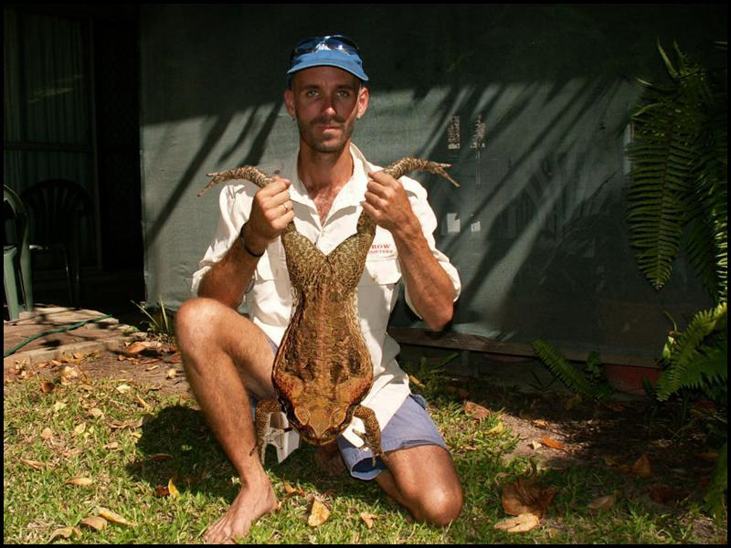
- The Cane toad was introduced to Australia to control cane beetles, pest insects that destroy sugar cane crops. Toads did not control cane beetles. Instead they have become an ecological disaster in Australia
  - Females breed once a year, __________________________________
  - _______________________________________________.
    - Toxins present on skin kill native predators
    - Toxic tadpoles kill aquatic predators
  - They were introduced to Queensland, Australia in 1935
  - Now they _______________________________________________________
- Invasive Species in British Columbia
Read page 142 and answer the following questions on each invader.

- How did this invasive species arrive in BC?

- Why is it so successful?

- How are people in BC trying to control it?

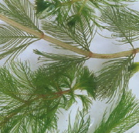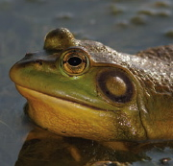
Eurasian Milfoil American Bullfrog
1) 1)

2) 2)

3) 3)

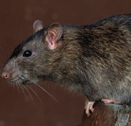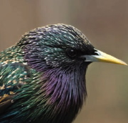
Norway Rat European Starling
1) 1)

2) 2)

3) 3)

Saving an Ecosystem Under Siege
- It often takes _____________________________________________________________________________________.
  - The Garry Oak Ecosystem Recovery Team (GOERT) is trying to save several areas of the Garry oak ecosystem in British Columbia.
  - ___________________________________________________________ has been lost to urban development, and the remaining _______________________________________________________________________________.
  - Garry oak trees are a _______________________________________.
  - Scotch broom, English ivy, grey squirrel, gypsy moth larva and other plant species are its biggest threats.
  - GOERT has representatives from many groups including the __________________________________
___________________________________________________________________________
  - Garry oak forests may be better suited to survive in the future.

