Science 10 – Chapter 5.1 - Acids and Bases Name ________ Date _______
- We already know how to classify compounds based one the type of bond they form.
    - _____________________: electrons transferred, ions made. (metal + non-metal)
    - _____________________: electrons shared. (non-metal + non-metal)
- We can also classify compounds into many other categories:
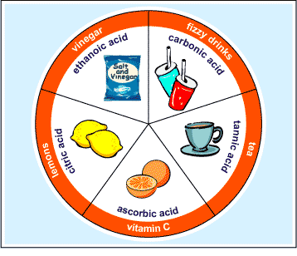
- ____________, _____________, salts, organics, inorganics
ACIDS and BASES
- Some Common Acids:
  - Citrus juice - _________, lemon and____________. Vinegar, tomatoes.
  - Anything with a ______________ taste.
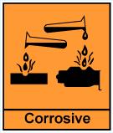
- We often add acids to our foods to improve taste and help us to absorb nutrients.
CAUTION!!!
  - Many Acids are _______________ which means they can burn your skin.
  - Never attempt to identify an acid by touch or taste!
- Some Common Bases:
  - Eggs, ___________________, soap ________________________________
  - Anything with a _____________ taste and/or a ____________________ feel.
CAUTION!!!
  - Many Bases are ______________________ which means they can burn your skin. (corrosive and caustic are basically the same meaning, just done by different chemicals)
  - Never attempt to identify a base by touch or taste!
The ____________ Scale:
A number scale for measuring how _____________ or __________________ a solution is.
pH below ____ = _____________ pH ____ = ___________ pH above ____ = _________
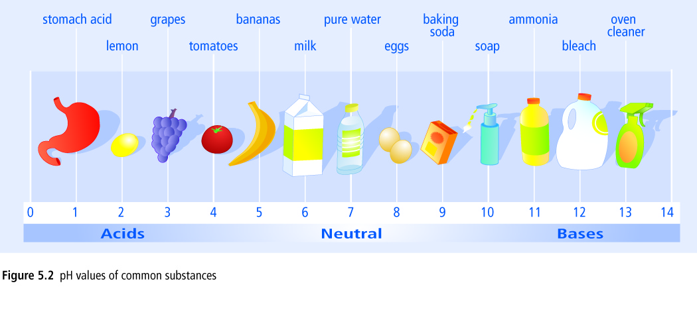

What do the numbers mean?
Each decrease of _______on the pH scale indicates _________more acidic.
    - For example, pH 4 is ___________ more acidic than pH 5
    - pH _____ is _______________more acidic than pH ______
    - pH ______ is 100 x more acidic than pH 5
What is pH Really Measuring?
The pH of a solution refers to the _________________________ of its _______ions.
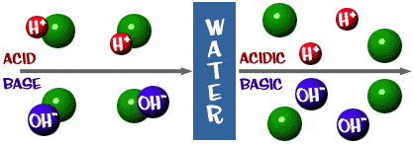
CONCENTRATION is the _________________ of substance (solute) ________________ in a given ______________________ of solution.
Square brackets are used to signify concentration, [H⁺], [OH–]
High [H⁺] = _____________ pH, very _____________________
High [________] = _____________ pH, very _____________________
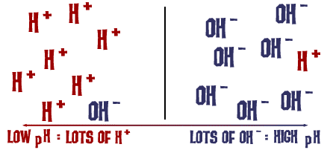
More about pH

If a substance has a lot of _________ions then it has a low pH.
If a substance has a lot of __________ions then it has a high pH.
If a substance has the ______________ amount of H⁺ ions as it has OH⁻ ions then it is _________________.
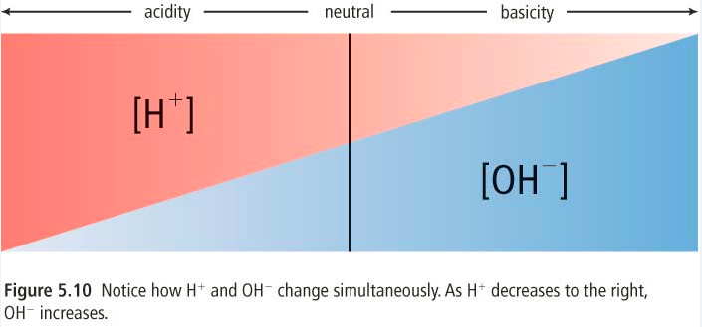

pH Indicators
The pH of acids and bases cannot directly be determined by __________________.
- Instead, pH is measured by other chemicals called ___________________or by a pH _______________________ that measures the _______________________ _____________ of the solution.
pH indicators change ___________________ based on the solution they are placed in.

pH and _______________ Paper
Litmus is the most common indicator, and is used on litmus paper.
Two colours of litmus paper:
Blue Red
pH above 7 (basic) ____________ pH above 7 (basic) ______________
pH = 7 ___________ pH = 7 ___________
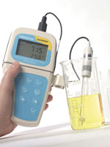
pH below 7 (acidic) ____________ pH below 7 (acidic) _____________
Memory device:
_________________ = _______________ + ____________________________
pH Probes
A pH ____________________ uses electrical probes to measure how solutions ____________________ electricity.
We said that acids and bases like to form _____________________ and ________________________ when in solutions and the __________________________of these ions will determine a solution's ___________________________ conductivity.
More about ____________
- Acids readily react with _____________________ to produce _______________________.
- We can also identify Acids by looking at their chemical _____________________.
- The chemical formula of an acid usually starts with hydrogen _______________.
- Acids with a carbon usually have the _________ written _______________.
  - Acids often behave like acids only when dissolved in ___________________ and so they often have the subscript _________
- Acids _________________ electricity because they release hydrogen ions, __________{(aq)}
Common Acids
    - __________________= hydrochloric acid ___________________= nitric acid
    - __________________= Sulphuric acid ___________________= acetic acid

More about Bases
- We can also identify Bases by looking at their chemical formula.
- The chemical formula of a base usually ______________ with __________________________
- Bases release hydroxide ions _________________{(aq)}

- Bases often behave like bases only when __________________ in water and so they often have the subscript (aq)

- Don’t readily react with metals
Common Bases
  - ___________________– Sodium Hydroxide ___________________– Calcium Hydroxide
  - ___________________– Magnesium Hydroxide ___________________– Ammonium Hydroxide
Acids | Bases
pH _____ than _______, corrosive | pH _____ than _______, caustic
Litmus turns ____________ | Litmus turns ___________
______________ electricity (when dissolved in water) | ___________ electricity (when dissolved in water)
Chemical Formula starts with ____ | Chemical Formula ends with ___
React with ______ to produce H₂ gas | Do not readily _______with metals

Review:
We can classify acids and bases based on:
- Their _____________________

- Their __________________________________________

- Their _____________________

- Their ______________________

- Their ______________________

What about _________________?
- What is a salt???
- Salts are _____________________ compounds formed when acids and bases react.
  - Salts are also produced when oxides or carbonates react with _________________ or when ________________react with acids.
- Table salt, ____________, is found in sea water, salt lakes or rock deposits.
- NaCl is only one kind of salt.
  - A salt is made up of a _________________ ion from a _________________ and a _______________ ion from an _________________________.
  - Salts are found in many things:
______________________________________________________________

