Science 10 – Chapter 5.2 - Salts Name ______________ Date _______
Acid-Base Neutralization
Salts are a class of __________________________________ that can be formed during the
____________________________________________________. They are composed of a
positive ion (__________________) and a negative ion (______________)

Neutralization reactions occur when an________ and a ________ react to produce a __________ and
______________________.
Eg. HCl(aq) + NaOH(aq) →
acid base salt water
Do practice problems on p 236

Metal Oxides and Non-Metal Oxides
___________________ react with water to form ______________.
Ex. _________________ + H₂O(l ) → _________________(aq)

_____________________ react with water to form _____________.
Ex. _________________ + H₂O(l ) → _________________(aq)
Non-metal oxides are formed from the ________________________________________
Add water in the atmosphere = ___________________________________

Acids and Metals
The most reactive metals, at the ______________________________________________, react
vigorously with ____________ and _______________.
All other metals are _________ reactive than those in groups 1 and 2.
When metals do react with acids, __________ gas is usually released and a ___________ is produced.
Ex. ______________(aq) + ________ (s) → ___________ (s) + ___________(g)

Do practice problems on p238

Acids and Carbonates
Carbonates (-CO₃) _______________ acids, protecting locations with natural carbonate supplies from
_______________________________.
Ex. H₂SO₄ + CaCO₃ → ___________ + ___________ + ____________
(acid) (carbonate) (salt) (water) (carbon dioxide)

Adding lime (calcium carbonate - CaCO₃) to a lake is called “liming.”
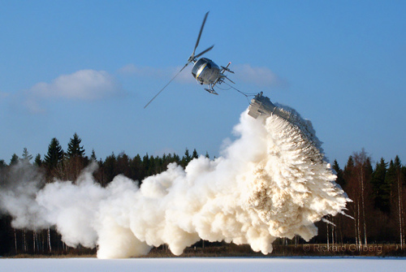

When and why would this be helpful?

Why is it not practical to always use liming?

