Science 10 – Chapter 5.3 – Organic Compounds Name ______________ Date _______
Organic vs. Inorganic Compounds - Another way of classifying chemical compounds…
- Every compound in the world is classified as either _______________, or __________________.
- Did you know that well over ________ of all known compounds on earth are Organic compounds??
Organic Compounds
- Organic compounds _______________ ________________ (and usually ______________________)
  - Sometimes other types of atoms near carbon on the periodic table are also attached, especially: _________________, ______________, sulfur, phosphorus and the halogens
Organics vs Acids
- Organic molecules always have ______________________________________________
CH₄ HC₄
- This differentiates organic compounds from acids, which almost always _________________. HCl
Is that why foods are called “organic”?
  - Organic actually derives from “______________________________”, because the compounds that plants and animals make are all C-compounds
  - This is not the meaning of organic foods though!
      - In this case organic foods refer to being _______________________________ (ironically many of these chemicals are actually ORGANIC compounds!)
Inorganic Compounds
- Inorganic compounds __________________________________… with _______________________:
  - _____________________________ and __________________________
  - Compounds containing cyanide (____________) and carbonate (_______________) ions
  - Examples: ____________________________________________________________
Why are Organic Compounds So Special?
  - Carbon has__________________________________________, which allows for __________ ___________________________________ than any other element.
    - Long chains of carbons form ______________________ and _________________
    - ______________________________________ (circular), _______________, and make ___________________________________ between carbons
There are ________________________ Types of Organic compounds. We only talk about two.
- _______________________________
- _______________________________
Hydrocarbons
- A ___________________ is an organic compound that ______________________ and __________.
Hydrocarbons are based on a carbon “backbone”, or chain, with hydrogen atoms added on the sides
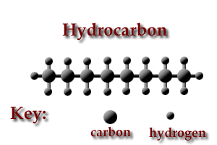
- You know about hydrocarbons already! The simplest hydrocarbons are ones that you might recognize
_______________ (CH₄)--- main component of natural gas
_______________ (C₂H₆)--- also found in natural gas
_______________ (C₃H₈) --- used as a fuel for BBQs
_______________ (C₄H₁₀) --- an extremely flammable fluid used in industrial torches
_______________ (C₈H₁₈)---a combustible liquid in gasoline
- All hydrocarbons are ____________________________, and most are liquids at room temperature
Alcohols
- ____________________________ are organic compounds with _______________________
- The simplest alcohols are:
__________________ (CH₄O)--- used in labs as a solvent (____________________________)
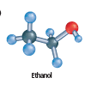
__________________ (C₂H₆O)---is a psychoactive drug (present in alcohol), but is now being considered as a fuel source
__________________ (C₃H₈O)---rubbing alcohol used to sterilize cuts
- Alcohols are generally very ______________________
Some different representations:
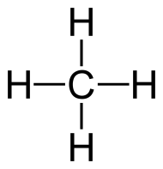
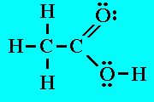
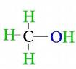
- Structural formula- lists the elements and their proportions in the order they are bonded

_______________ ______________ __________________
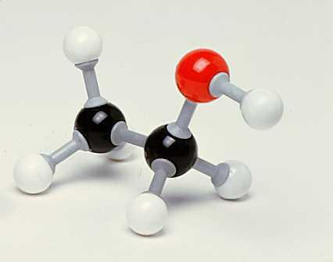
- Ball-and-stick model- each element is given a different colour and/or size and the picture shows how many and how the elements are bonded
Each black ball represents C…
Each white ball represents H…
The red ball represents O…
This is ___________________
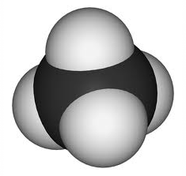
- Space-filling model- similar to a ball-and-stick model, but the balls are proportional to the sizes of the atoms.
This is ___________________

The First Five Hydrocarbons Name _______ Date ________
Name | Molecular Formula | Structural Formula | Shortened Structural Formula | Space Filling Model | Common Uses
methane
 |  |  | CH₃CH₃ |  | Manufacturing plastic
 | C₃H₈ |  |  |  | Camp fuel
 |  |  | CH₃CH₂CH₂CH₃ |  | Hand held lighters
pentane
Can you guess the names of the next 5 hydrocarbons?
The First Five Alcohols
methanol
 | C₂H₆O
 |  |  | CH₃CH₃CH₂OH
butanol
 | C₅H₁₂O

