**6.2 Factors Affecting the Rate of Chemical Reactions**

* Different chemical reactions take place at much different **___________________** or _____________________



* Often, ______________________________________of a chemical reaction is as important as having the reaction occur in the first place.
  + ___________________________________ can determine the rate at which a chemical reaction occurs.
* To make a reaction happen quickly:
  + **_______________________________________________** where the reaction occurs.
  + **______________________________________________** of reactants.
  + Increase the amount of **__________________________________** that reacts.
  + **__________________________________________** or remove an inhibitor.
* To make a reaction happen slowly:
  + **____________________________________________________** where the reaction occurs.
  + **___________________________________________________** of reactants.
  + **__________________________________________________** that reacts.
  + **________________________________________________** or add an inhibitor.

**Collision Theory**

* + 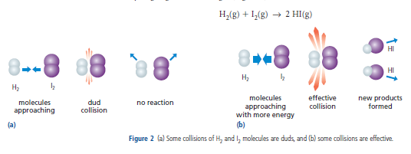Changing the **________________________________________________________** changes the reaction rate
* **_________________________________________________________**
  + Higher frequency of collision = **________________________________________________________**
  + 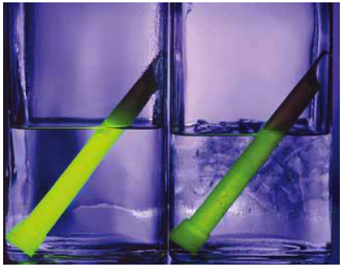Lower frequency of collision = **_________________________________________________________**

**Temperature**

* Temperature is the average energy of molecules.
  + The **________________________________________________**, the ________________________________molecules have.
  + When molecules have more energy, they move around more, **__________________________________________ _________________________________________________________**, and therefore _______________________________________
* The rate of reaction changes with the temperature.
  + **_________________________________________________________________________________________**
  + Sometimes we want slower reactions (we use a fridge to prevent food going bad).
  + Sometimes we want faster reactions (we cook food to speed up the production of new molecules).

**Concentration**

* 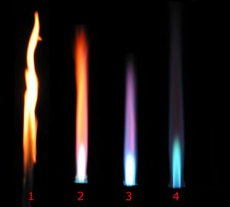**______________________________________** refers to how many molecules of a substance exist in a certain volume.
  + Concentration is how much solute is dissolved in solution.
  + Concentration is measured in mass per unit volume (g/L).
* Usually, the **______________________________________________________________________________________________________** 
  + Since there are more molecules per unit volume in high concentrations, there **__________________ ______________________________________________________________**.
  + 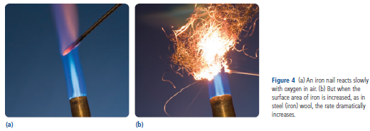A splint of wood glows brighter in highly concentrated oxygen than in normal air with a lower concentration of oxygen.

**Surface Area**

* Chemical reactions occur when and where atoms and compounds collide.
  + The __________ **______________________________________________________________________________________________.**
* **________________________________________________________________** the rate of reaction.
  + Surface area can be increased by _____________________________________________.
    - __________________________________has far more surface area than ___________________________________.
  + The increase in surface area must also be exposed for reaction; a powder only reacts more quickly if it is spread into the air instead of lying on a pan.

**Catalysts**

* Sometimes, increasing the temperature or concentration is not a desirable method to increase reaction rate.
  + Changing these two variables may be impractical or dangerous.
* A **_____________** is a chemical that allows a reaction to occur more quickly ________________________________________in the reaction itself.
  + The **______________________________________________** rate but does not get used up as a reactant.
  + Catalysts often lower the amount of energy necessary to break the bonds in the reactants.
* **________________________________** are an example of biological catalysts.
  + Saliva has enzymes that help speed the breakdown of starches when they enter the mouth.
* A **_________________________________________** is a device installed in cars to **________________________________________**.
  + Car exhaust passes through the catalytic converter before leaving the car.
  + Catalysts found in the honeycomb-shaped filters in the converter help to change many of the pollutants into less harmful substances.
    - Poisonous carbon monoxide is changed into CO2.
    - Hydrocarbons are converted into CO2 and H2O.
    - Nitrogen oxides are changed into N2 and O2.
      * 2N2O3 🡪 2N2 + 3O2