9.1 Describing Acceleration

An object traveling with uniform motion has _________________________________________________________

Not all objects exhibit uniform motion.

It is important to be able to analyze situations where the motion is **not uniform**.

An object travelling with non-uniform motion will:

* have different ____________________________________________________________________________________
* take different amounts of _______________________________________________________________________
* have a ______________________________________________________________________________

**Positive and Negative Changes in Velocity**

A change in velocity _____ occurs when the ___________ of an object changes and/or its __________________ of motion changes.

A change in velocity can be calculated by:

If the change in velocity is the same sign (+, -) as the initial velocity, the speed of the object is _____________________.

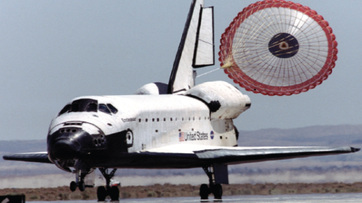If the change in velocity is the opposite sign (+, -) of the initial velocity, the speed of the object is ___________________.

If the change in velocity is zero, the object is travelling with __________________ ____________________.

**Acceleration**

Acceleration (*a*) is the _________________________________________________________________________________.

This change in velocity can be due to a change in _____________and/or a change in _________________.

Two objects with the same change in ________________ can have different __________________________.

This is because acceleration describes the rate at which the change in velocity occurs.

**Positive and Negative Acceleration**

The direction of the acceleration is the same as the direction of the ________________________________.

Acceleration that is opposite the direction of motion is sometimes called _________________________.

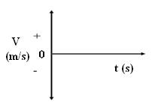Acceleration can be described in a_______________________________________. BE CAREFUL not to confuse this with a **position-time** graph!

Examples of acceleration:

1. A car ____________________________________________________

If we designate the ______________ direction as positive (+), then the change in velocity is ________________ , therefore the acceleration is ________________ .



2. A car ______________________________________________________.

If we designate the forward direction as positive (+), then the change in velocity is ________________, therefore the acceleration is _________________ .

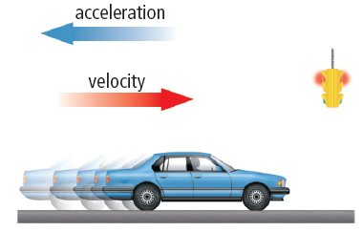

3. A car ___________________________________________________________.

If we designate the backward direction as negative (-) then the change in velocity

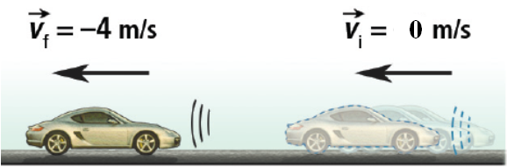is ______________________________________.



This means that the acceleration is ________________ even though the car is increasing its speed. **Remember positive (+) and negative (-) refer to directions**!!!!

4. A car ____________________________________________________.

If we designate the backward direction as negative (-) then the change

in velocity is ___________________________

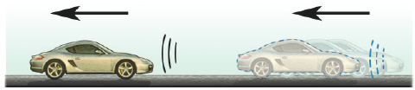



This means that the acceleration is _______________ (+) even though the car is decreasing its speed. **Remember positive (+) and negative (-) refer to directions!!!**

**Zero Acceleration**

5. A car is _______________________________.

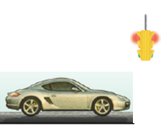 The change in velocity is ____________. __________________________.





6. A car has ____________________________________.

 The change in velocity is ________________.

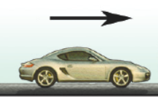



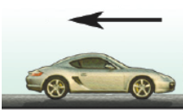



This means that the acceleration is **______________. _____________________________________________________ _________________________________________________________________**