9. 2 Calculating Acceleration

* The acceleration of an object depends on the _____________________________________ and the _______________ required to change the velocity.
* 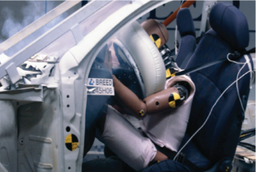When stopping a moving object, the relationship between time and acceleration is:
  + Increasing the stopping time_________________________________________________.
  + Decreasing the stopping time _______________________________________________.

**Velocity-Time Graphs**

* The motion of an object with uniform motion can be represented by a position-time graph.
* The motion of an object with a changing velocity can be represented by a_____________________________.
* 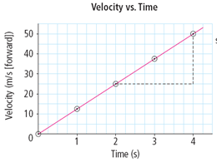The slope of a velocity-time graph is_______________________________________.
* Acceleration is _______________________________________

**Determining Motion from a Velocity-Time Graph**

* A velocity-time graph can be analyzed to describe the motion of an object.
  + Positive slope (positive acceleration) – object’s ________________________________________________

or the object’s velocity is ___________________________________________________

* + Zero slope (zero acceleration) – object’s ___________________________________________
  + Negative slope (negative acceleration) – object’s velocity is _______________________________________

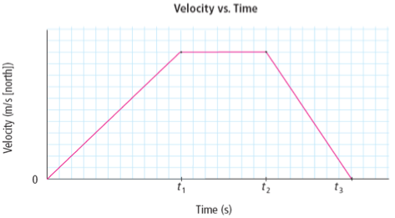 or the object’s velocity is ___________________________________________________

State during which time interval:

1. the acceleration was zero.
2. the acceleration was negative.
3. the acceleration was positive.
4. the object was increasing its velocity north.
5. the object was decreasing its velocity north.
6. the object was moving at a constant velocity north

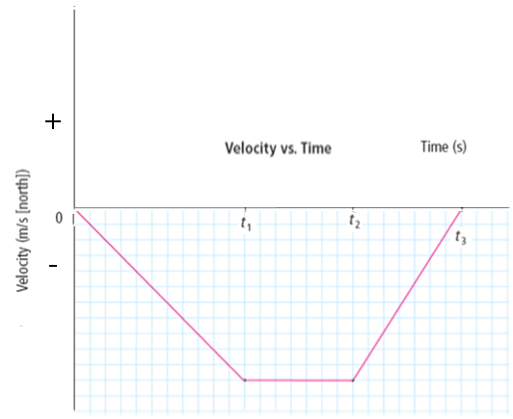State during which time interval:

1. the acceleration was zero.
2. the acceleration was negative.
3. the acceleration was positive.
4. the object was increasing its velocity south.
5. the object was decreasing its velocity south.
6. the object was moving at a constant velocity south

**Calculating Acceleration**

* The relationship of acceleration, change in velocity, and time interval is given by the equation:

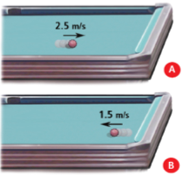Example: A pool ball travelling at 2.5 m/s towards the cushion bounces off at 1.5 m/s. If the ball was in contact with the cushion for 0.20 s, what is the ball’s acceleration? (Assume towards the cushion is the positive direction. (+))

* The relationship of change in velocity, acceleration, and time interval is given by the equation:

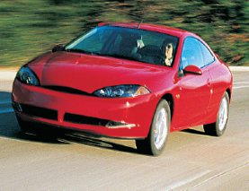Example: A car accelerates from rest at 3.0 m/s2 forward for 5.0 s. What is the velocity of the car at the end of 5.0 s?

The car’s change in velocity is 15 m/s forward, therefore

________________________________________________________

* The relationship of time interval, change in velocity, and acceleration is given by the equation:

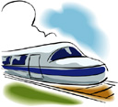Example: A train is travelling east at 14 m/s. How long would to increase its velocity to 22 m/s east, if it accelerated at 0.50 m/s2 east? Assign east direction positive (+).

Try the following acceleration problems.

1. A truck starting from rest accelerates uniformly to 18 m/s [W] in 4.5 s. What is the truck’s acceleration?
2. A toboggan moving 5.0 m/s forward decelerates backward at -0.40 m/s2 for 10 s. What is the toboggan’s velocity at the end of the 10 s?
3. How much time does it take a car travelling south at 12 m/s to increase its velocity to 26 m/s south if it accelerates at 3.5 m/s2 south?



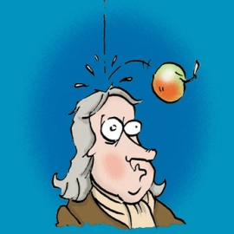9. 2 Gravity and Acceleration

* Objects near the surface of Earth fall to Earth__________________________________.
  + Gravity is ______________________ that acts between two or more masses.
* _________________________________ is a friction-like force that ______________________________of objects that move through the air.
* Ignoring air resistance,___________________________________________________________________.
  + 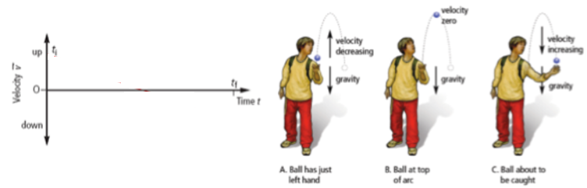The acceleration due to gravity is______________________________.

**Calculating Motion Due to Gravity**

* To analyze situation where objects are accelerating due to gravity, use the equations:
* In these equations, the acceleration ( ) is 9.8 m/s2 downward.

Example: Suppose a rock falls from the top of a cliff. What is the change in velocity of the rock after it has fallen for 1.5 s? Assign “down” as negative (-).

Since down is negative _________________________________________

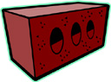Try the following acceleration due to gravity problems.

1. What is the change in velocity of a brick that falls for 3.5 s?
2. A ball is thrown straight up into the air at 14 m/s. How long does it take for the ball to slow down to an upward velocity of 6.0 m/s?
3. A rock is thrown downwards with an initial velocity of 8.0 m/s. What is the velocity of the rock after 1.5 s?