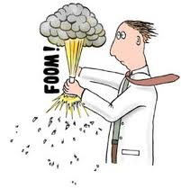**Writing and Balancing Chemical Equations**

**Chemical Equations**

* Chemical ______________________ result in _________________________.
  + Chemical changes occur when _______________________________________.
  + The original substance(s), called _______________, change into new substance(s) called _________.
* Chemical reactions can be written in different ways.
  + A ____________ equation:
    - nitrogen monoxide + oxygen 🡪 nitrogen dioxide

State of matter

* Letters indicate the state of each compound.
* (aq) = ____________________
* (s) = ___________________
* ( ) = __________________
* (g) = _________________
  + A ________________ equation:
    - 2NO(g) + O2(g) 🡪 2NO2(g)

__________________

* Indicate the ratio of compounds in the reaction.
* Here, there is twice as much NO and NO2 than as is O2.

**Conservation of Mass in Chemical Change**

* Chemical change means new compounds are created.
  + __________________________________________________________; atoms are just rearranged.
  + ___________ of the matter in the _________________ = ______ of the matter in the ___________.
  + Number of each atom in reactants = number of each atom in products.
* The _________________________________________________________:
  + In chemical reactions, atoms are ______________________________________________________.
  + Mass of reactants = mass of products

**Writing and Balancing Chemical Equations**

* The simplest form of chemical equation is a ________________________________.
  + potassium metal + oxygen gas 🡪 _________________

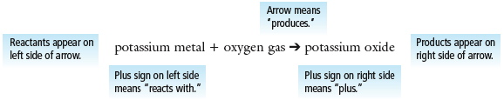

* A _____________________________________________ shows the formulas of the elements/compounds.
  + A skeleton equation ________________________, but _____________________ of atoms.

K + O2 🡪 K2O

* A ____________________________ chemical equation **shows all atoms** **and their quantities**
  + Balancing ensures that the ___________________________________________________________ of the reaction arrow.
  + Always use the smallest whole-number ratio.

Balance: K + O2 🡪 K2O __________________________________



🡪 Word equation

🡪Skeleton equation



# of atoms 🡨

Counting Atoms: 2 Methods, same meaning.

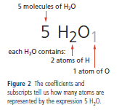

These two diagrams/equations look different, but both represent the same thing.

**Counting Atoms**

**🡪**

**Counting Atoms to Balance an Equation**

* 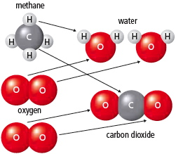Using the law of conservation of mass, we can _____________________ to balance the number of atoms in chemical equations.
  + Word equation: methane + oxygen 🡪 water + carbon dioxide
  + Skeleton equation: ___________________________________ 
    - To balance the compounds, look at how many atoms of each element occur on each side of the reaction arrow.
  + Skeleton equation: CH4 + O2  🡪 H2O + CO2

1 carbon, 4 hydrogen, 2 oxygen 🡪 1 carbon, 2 hydrogen, 3 oxygen

* + To balance, find _______________________________ that equate atoms on both sides
  + Balanced equation: _______________________________

1 carbon, 4 hydrogen, (2×2) oxygen 🡪 1 carbon, (2×2) hydrogen, (2×1)+2 oxygen

**Practice**: Balance H2 + O2 🡪 H2O





**Strategies for Balancing Equations**

* Balance chemical equations by following these steps:
  + Trial and error will work but can be very inefficient.
  + Balance compounds first and elements last.
  + Balance one compound at a time.
  + Only add coefficients; NEVER change subscripts.
  + If H and O appear in more than one place, attempt to balance them LAST.
  + Polyatomic ions (such as SO42–) can often be balanced as a whole group.
  + Always _________________________ after you think you are finished.
* Balance the following:
  + Fe + Br2 🡪 FeBr3
  + Sn(NO2)4 + K3PO4 🡪 KNO2 + Sn3 (PO4)4
  + C2H6 + O2 🡪 CO2 + H2O