**Chapter 8 Practice** Name: Date:

1. Usain Bolt set the world indoor track record in 2009 by running ***north*** 100 m in 9.58 s. What was his *average velocity*? **Show all your work**

2. A boat travels across a 45 km lake with an average forward velocity of 15km/h.

a) How *many hours* does it take for this boat to cross the lake? **Show all your work**

b) How fast is the boat going in m/s? **Show all your work**



3.

1. 0 s – 20 s



1. 20 s – 30 s
2. 50 s – 60 s

4. The motion of an elevator is represented by the position-time graph below. Describe, using words, the motion of the elevator during the 30 s time interval. **(3 marks)**



5. Draw a Position-Time graph for the following situation, and label each axis.

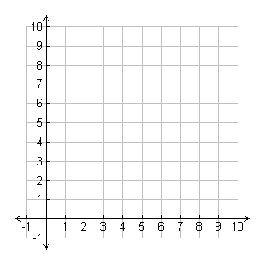A student rolls a ball toward a wall *with uniform motion*. The ball hits the wall and rolls back to the student *with uniform motion*. The student catches the ball and after a few second rolls it to the wall again, except with a faster velocity. The ball once again hits the wall and comes back to the student who catches it. **Use the origin as your reference point.**

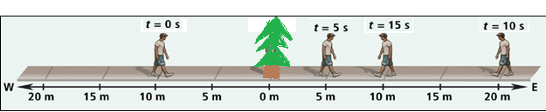

6.

A man starts walking from a position 10m [W] of a tree. He continues until he is at a position 20m [E] of the tree and turns around and walks until he is at a position 10m [E] of the tree. Complete the following table.

|  |  |  |  |  |
| --- | --- | --- | --- | --- |
| Time Interval |  |  | Displacement | Distance |
| 0s – 5s |  |  |  |  |
| 0s – 10s |  |  |  |  |
| 0s – 15s |  |  |  |  |
| 5s – 15s |  |  |  |  |