Ecosystems Portfolio

Biome Region ______________ Name______________

Check List
- Abiotic Information
- Map – Location of biome region, oceans, mountain ranges, distance from equator
- Analysis of the map questions
- Climate - average temperature and rainfall – compare winter vs summer
- Geological features – landscape and soil
- Summarize: How is the location of your biome region affecting its climate?

- Climatograph
- City or country from your biome region – include a map
- Correct format (temp = line, precipitation = bars) and axis labelled
- Hand drawn or computer generated
- Description of the climate of your biome region – based on the climatograph

- Two Examples of Adaptations
- Two different organisms (named)
- Pictures of each organism
- Explanation of why the adaptations have occurred. In other words, why are these changes beneficial?

- Symbiosis
- Picture, correct type and description given

- Food Chain
- 3 Organisms minimum
- Include pictures/names of the organisms
- Arrows show the energy flow
- Trophic levels correctly labeled

- Pyramid of Energy, Biomass or Number
- Include pictures/names of the organisms
- Same organisms as food chain
- Include trophic levels

- Food Web
- At least 10 organisms – with names and pictures
- Arrows show the energy flow
- Lots of connections
- Trophic levels indicated through a legend

- Nutrient Cycles
- Paragraph explaining what happens in the carbon cycle
- Paragraph explaining what happens in the nitrogen cycle
- Paragraph explaining what happens in the phosphorous cycle

- Bioaccumulation
- Give an example of bioaccumulation – what is the chemical and how does it affect organisms in the ecosystem as it biomagnifies?
- Keystone species – with name and picture. Is it affected by bioaccumulation? Impact on ecosystem?

- Foreign Species
- Example of a foreign species, name, picture
- Description of how the foergin species has impacted the native species in the biome region

- Final Product
- All documents put in order according to your table of contents or assembled into a large presentation board

- Bibliography
- All pictures correctly cited in MLA or APA format
- At least 5 sources correctly cited in MLA or APA format

Today you will learn about the abiotic factors that affect the climate of your biome region:

- Distance from the equator (latitude)
- Proximity to oceans
- Nearby mountain ranges

You will need to research and fill in the information required in each section of the following table: biome map, organisms, climate and geological features. This is due next day.
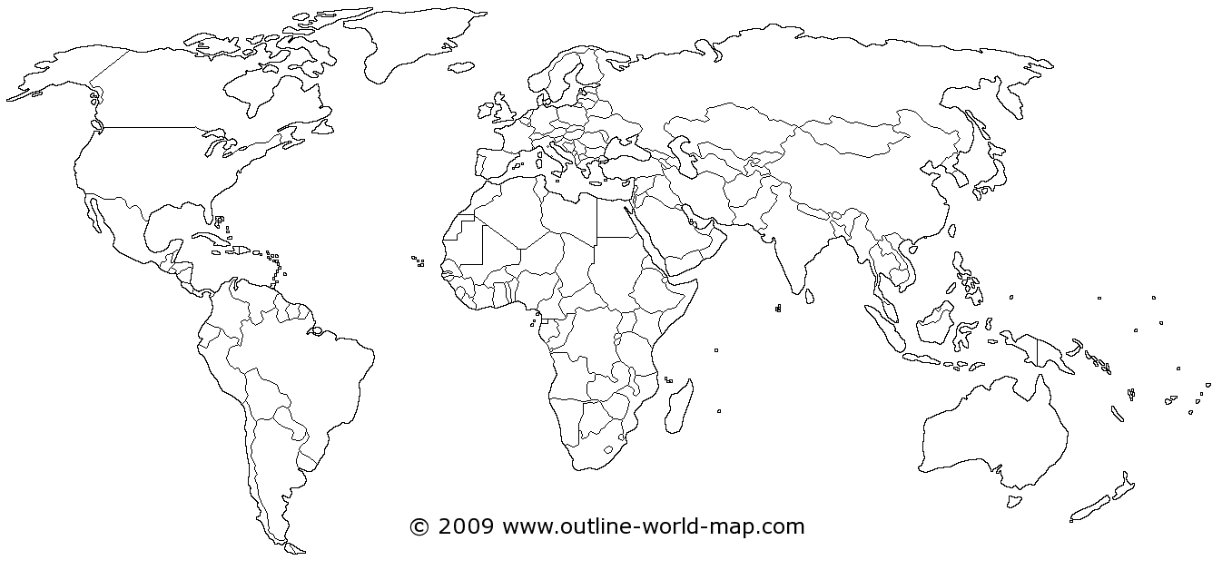
- Biome Map
- Outline where your biome region is located
- Label the oceans that are near your biome
- How far from the equator is your biome region? (is it near the Tropic of Cancer / Capricorn or near artic/antarctic circle?)
- Label any mountain ranges in your biome

- Analysis of the Map

