GO TO http://www.bced.gov.bc.ca/exams/search/
(You MIGHT need to use Microsoft Explorer or Firefox – I had a problem with Google Chrome)

Choose the options shown in the picture below.
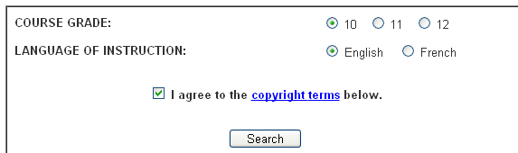
Click “Search” then in the following screen, choose science 10.
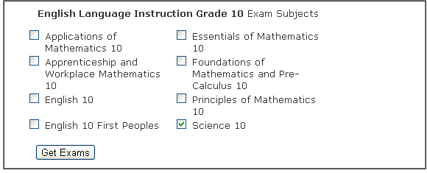
Click “Get Exams”
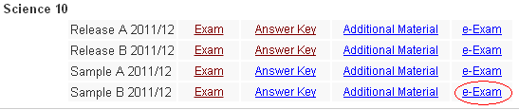
Click “e-Exam” by Sample B 2011/12
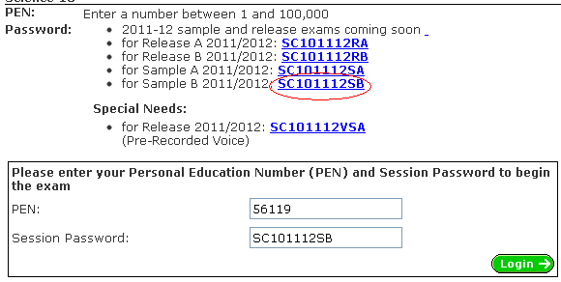
Choose “SC101112SB” and click “Login”
Follow the instructions from there by clicking the “Next” button on the bottom right side.
Science 10 Practice Provincial Exam Name ____________
Instructions:
- Find the exam “SC101112SB” by following the instructions on the back of this paper.
- Complete the exam. You may use a calculator. If you choose, you may use your notes and textbook for reference.
- Write the total time it took you to complete and check your exam.

My Time _______________________

- Follow the instructions to mark your exam. What was your total score?

My Score ______ / 80

- Write the numbers of 10 questions you got wrong. (If you get less than 10 wrong, write any that you got wrong)

My wrong answers _______________________________________________________________________

- Which questions were the most difficult? Unit 1, unit 2, unit 3 or unit 4? _________________________
Unit 1: Earth’s Ecosystems - Biomes, ecosystems, energy flow, nutrient cycles
Unit 2: Chemistry - Atomic theory, chemical bonding, chemical equations, acids/bases/salts, chemical reactions,
radioactive decay, half-life, nuclear reactions
Unit 3: Motion - Distance, displacement, velocity, acceleration
Unit 4: Energy Transfer – kinetic molecular theory, thermal energy, climate change, continental drift, plate tectonics, earthquakes, volcanoes

- Write ten words on the test that you didn’t know or weren’t sure about.

- _________________ 6. __________________

- _________________ 7. __________________

- _________________ 8. __________________

- _________________ 9. __________________

- _________________ 10. _________________

- What are the most important things for you to study? Focus on your weak points first!

- What will YOU do to prepare for the science provincial exam?

