Safety in the Science Lab Name _______________ Date _________________
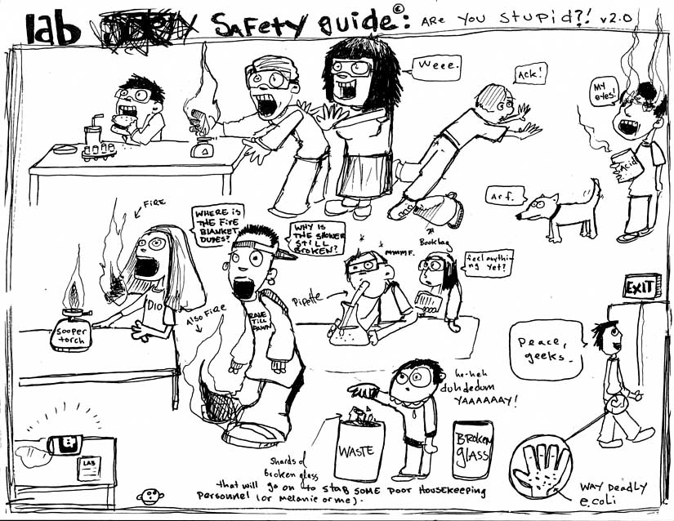
On the front of this page, circle unsafe things that are happening in this science lab. On the back of this page, write (in sentences!!) the way to correct all the problems you circled on the front. You should be able to find at least 10!

